NCTS-PDA4W Industrial Smart Handheld Terminal
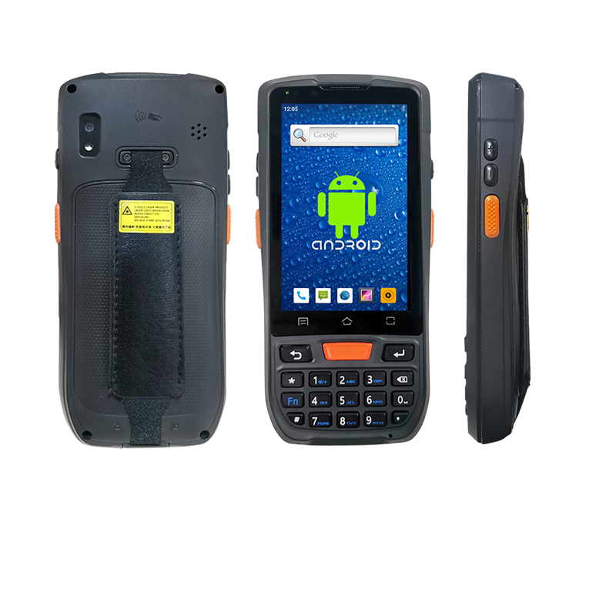
Camera
NFC identification

QR code Reader

Waterproof, anti-fall, dustproof
- inch HD full screen · High-speed quad-core · Android 9.0 system
i
Bluetooth
WIFI
1D Code
Android
4G

GPS
Camera
NFC
PSAM
QR Code

WPC-9080 is developed based on Android 9.0 operating system, adopts high-performance processor, quad-core CPU, supports dual frequency WiFi and high-speed 4G communication, high running speed and saves power.
Users can develop customized functions according to your needs, helping users quickly realize information management and improve production efficiency.

Product parameters

Physical parameter
Overall size | 157（H）*73（W）*21.6(T)mm（Scan head 26mm）
Total Weight | 280g（Including battery, weight varies in different configurations）
Display | 4 inches, 480 * 800 resolution, 16.7M colors
Touch screen | Industrial capacitive touch screen
Battery capacity | Polymer li-ion battery 4300mAh
 | Standby time> 300 hours
 | Working time> 12 hours（Depends on usage and network environment）
 | Charging time 3-4 hours (use the standard power adapter and data cable)
Expansion slot | 1 SIM card slot, 1 Micro SD (TF) card slot supports up to 128GB
Communication Interface | USB Type-C, Support OTG function, support Pump Express Plus fast charge
Audio | Microphone, handset, 1W speaker, support voice call
keyboard | 3 TP keys + 5 side keys + keyboard
Sensor | Light sensor, distance sensor, gravity sensor, vibration motor
Power Adapter | 100-240V，50-60Hz，0.29A；output：5V，2A
Performance parameter
High version | CPU: Cortex A-53 2.0 GHz Quad-core
 | RAM+ROM: 2GB+16GB
Extended memory | Micro SD (TF) card expandable to 128GB
Development environment
Operating system | Android P (Android 9.0) supports GMS certification
Development language | Java
Development tools | Eclipse/Android Studio
Use environment
Operating temperature | -20oC to 50oC
Storage temperature | -40oC to 70oC
Environment humidity | 5%RH - 95%RH（Non-condensing）
Drop specifications | 1.5m cement floor
Rolling test | 1000 rounds of 0.5 meter rolling (equivalent to 2000 impacts)
Electrostatic discharge (ESD) | ± 15kV air discharge, ± 8kV direct discharge
WLAN | Support IEEE802.11 ac / a / b / g / n protocol (2.4 / 5G dual frequency),
WWAN | GSM：850/900/1800/1900Mhz)
 | TD-SCDMA：Band34,Band39
 | WCDMA：Band1,Band2,Band5,Band8
 | TDD-LTE：Band38,Band39,Band40,Band41
 | FDD-LTE：B1/B2/B3/B4/B5/B7/17/B20
Bluetooth | Bluetooth 4.1（support HS）
GNSS | Integrated GPS, Beidou, GLONASS, built-in antenna, support AGPS
Data collection
1D scanning engine | Honeywell N4313 / UE966 / Zebra SE965
Support 1D barcode type | UPC/EAN,Code128,Code39,Code93,Code11,
 | Interleaved 2 of 5, Discrete 2 of 5, Chinese 2 of 5,
 | Codabar,MSI,RSS ect.
2D scanning engine | Zebra SE4710 / Autonomous 2D engine
Support 2D barcode type | PDF417, MicroPDF417, Composite, RSS, TLC-39,
NFC(Optional)
Frequency | 13.56MHz
Protocol standard | ISO14443A/B, NFC-IP1, NFC-IP2 ect
Labeling standards | M1 card (S50, S70), CPU card, NFC tag, etc.
Reading distance | 2-4cm

PSAM(Optional)
PSAM | Support ISO7816 standard, 2 PSAM cards

