NCTS-RP4 80MM Thermal Receipt Printer
User Manual
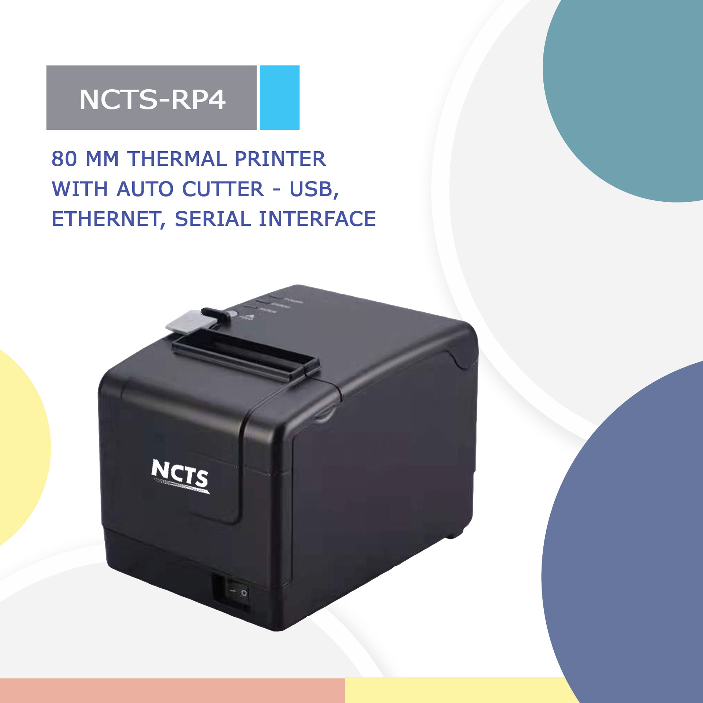

Please read this manual carefully before using it, and keep it for future reference
About this manual
Thanks for your purchase of our company's 80MM thermal printer.
This manual can help you to use this product. Please read this manual before use, and safekeeping, so that all the user of this product can read it.

Note
Due to our constant efforts to improve and upgrade the product's function and performance, our company reserves the right to change the hardware and software specifications of the manual without prior notice.
If you find any errors or missions in the contents of this manual, please tell us or our agent, thank you very much.
Without the prior written permission of our company, the contents of the relevant manual attached to the product shall not be reproduced, transmitted, transcribed, stored, etc.

Statement
This product is type A product, may cause the wireless radio interference in the living environment, in this case, the user need to protect the interference with effective protection measures.

Safety tips
●Do not disassemble the printer personally, please read this manual before use.
●The printer should be installed in a stable place to avoid damage to the printer due to vibration or shock.
●Do not store and use the printer in the environment of high temperature, high humidity, and heavy pollution.
●The power adapter of the printer should be connected to the grounding socket. Avoid to use the same socket with other large motor or other equipment can lead to voltage fluctuation. Otherwise, it may lead abnormal to printer and even damage to the printer.
●Please use the standard power adapter to the printer.
●When connect to printer, please make sure the printer is in power off status.
●When the printer is printing, please do not open the paper cover, otherwise it may cause unexpected situation, and even damage the printer.
●After printing, print head is still in high temperature, please do not touch, to avoid burn.
●Please do not use dissolved substances, such as: benzene, thinner or alcohol wipe to clean the printer casing. At the same time, please do not use corrosive chemicals and detergent to contact printer. To avoid damage to the printer.
●Please use our company approved or regular factory produced printing paper, otherwise it may lead to poor print quality, and even damage the printer core.
●How long the letters can stay on the receipt is related to thermal paper quality, if you want to print the long-term preservation bills, please choose a high quality thermal paper.
●The printer is only suitable for using in the altitude below 2000M.
●The printer is only suitable for use in non-tropical climates.

Application Area:
●Electronic cash register POS system printing
●Electronic transfer POS system printing
●Sports, postal, civil aviation bill printing
●Query, service system bill printing
●Catering industry bill printing
●Tax bill printing

Package:
●Printer 1PC
●Standard power adapter (including power line) 1SET
●Paper roll 1ROLL
●Data line 1PC
●User manual 1PC
●Driver CD 1PC

Printer Features：
●Support vertical placing and printing;
●Ultra-low power consumption, and ultimate power saving;
●Support billing coming reminder and error warning function;
●Support wall hanging function, meet the special environment printing;
●Support 80MM large diameter roll;
●Support kitchen printing and Internet printing;
●Support printer monitoring function, to avoid losing bills;
●Using 100M Ethernet card, Printing more fast and fluently.
●Re-printing after network disconnection, to avoid lose bills;
●Support LOGO Graphical download and print;
●Support 1D bar code printing;
●Support GB18030 large character library, easy to print uncommon words;
●Support Multi language printing;
●Rich Interface: USB, Serial, Internet, Bluetooth, WIFI, etc. (Interface combination, please contact manufacture to confirm)
●Compatible with ESC/POS print instruction mode;
●Support Windows, Linux, Android and IOS system;
Printer Parameters:
Item |  | Parameters
Print parameters | Printing Method | Thermal Line
Print parameters | Printing width | 72mm
Print parameters | Resolution | 8dots/mm,203dpi
Print parameters | Print speed | 200mm/s(Max)
Print parameters | Line Spacing | 3.75mm（Can adjust line spacing by command）
Print parameters | Line No. | FontA-48Lines/FontB-64Lines/Simple, traditional Chinese-24 lines
Print parameters | Character | Standard GB18030 simplified / BIG5 traditional Chinese Fonts(Japanese and Korean optional)
Print parameters | Character Size | ANK character:  Font A:1.5X3.0mm(12x24dot)  Font B:1.1X2.1mm(9x17dot)  Simple/Traditional Chinese: 3.0x30.mm(24x24dot)
Print parameters | Extended character set | PC437/Katakana/PC850/PC860/PC863/  PC865/West Europe/Greek/Hebrew/  East Europe/Iran/WPC1252/PC866/PC852/  PC858/Latvian/Arabic/PT151,1251/  PC737/WPC/1257/Thai Vietnam/PC864/  PC1001/(Latvian)/(PC1001)/(PT151,1251)/  (WPC1257)/(PC864)/(Vietnam)/(Thai)
Bar code Character | Bar code | 1D bar code：UPC-A/UPC-E/JAN13(EAN13)/JAN8(EAN8)/CODE39/ITF/CODABAR/CODE93/CODE128
Bar code Character | Graphics printing | Supports bitmap download and print (Each bitmap size max to 20k)
Cutter | Cutter Function | Full cut/Half cut
Paper | Type | Thermal Paper
Paper | Width | 79.5±0.5mm
Paper | Diameter | ≤82mm
Paper | Feed method | Easy feed(Clamshell feed)
Print commands | Commands | ESC/POS
Power | Power Adaptor | Input：AC 100V-240V, 50～60Hz  Output：DC 12V/2A
Power | Cash Drawer output | DC 12V/1A
Buffer | NV Flash | 256K bytes
physical characteristics | Weight | 1.2KG
Environment | Dimension | 195*148*145(MM)
Environment | Working | Temp：5 ~ 45℃， Humidity：10 ~ 80%
Reliability parameter | Storage | Temp：-10 ~ 50℃ ，Humidity：10 ~ 90%
Reliability parameter | Cutter Life | 1000,000times
Software | Print Head Life | 100KM（print density≤12.5）
Software | Driver | Android,IOS,Linux,Windows

Printer connection
1. Connect the power adapter cable with printer.
2. Connect the data cable(eg: USB line) with printer also.
3. Connect Cash drawer line with printer as well.

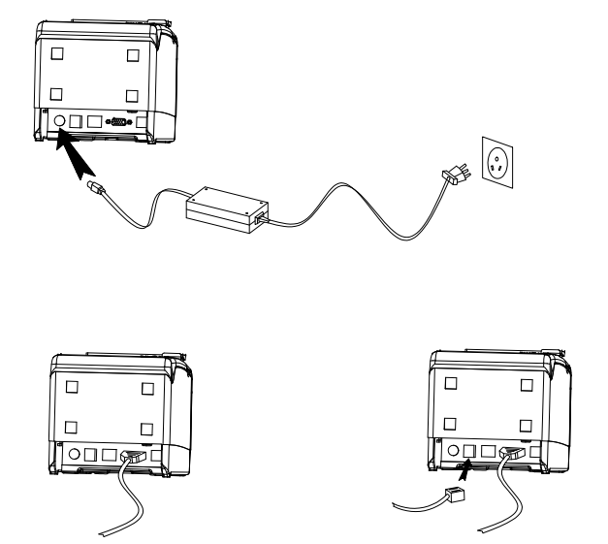

Install thermal paper
80MM series thermal printer using 80MM thermal paper, using easy paper structure, convenient to install paper.
1 Pressing down the opening button, open the printer cover
2 Put thermal print paper in the paper holder according to the pic below
3 Pull a little paper out of the warehouse
4 tear excess printing paper
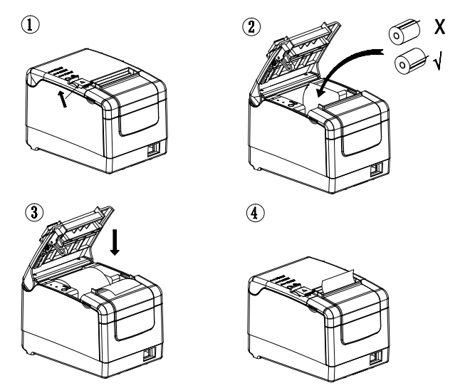
Note: take care of the roll direction, if reverse direction, the content won’t be print out.

Power switch, press bottom, indicators and their functions
1 Power switch button
The switch can turn on and off the printer power supply.
2 Feed button
Press this button can feed the paper out, if keep pressing, will continue to feed.

3 Paper light indicator
When this paper light and the Error light flashing at the same time, it indicates printer is lack of paper; When this paper light and the Error light are off, means the printer has paper.
4 Power light indicator
This light on indicates that the printer is connected to the power supply, this light off indicates that the printer power is off.
5 Error light
When Lack paper in printer; or cutter have problem; or the print head is overheated; or the cover is not closed properly, this error indicator will flash.

How to print a self-test page?
Connect printer with the power adapter, press feed button and turn on power button at the same time, keep pressing the feed button until the paper light turn off and then release the feed button, you will see a self-test page printed. In self-test page, it shows the current printer status and setting details.

How to set the beep function close or open?
Connect printer to the power adapter, press feed button and turn on power button at the same time, keep pressing the feed button until the Paper light and error light all turn off, then release the feed button, then you will see the beeper have been set closed / opened.

How to set printing density?
Connect printer to the power adapter, press feed button and turn on power button at the same time, keep pressing the feed button until the Paper light and error light all turn off, and paper light turn on, then release the feed button, then you have set the printing density successfully.

How to back to factory setting:
Connect printer to the power adapter, press feed button and turn on power button at the same time, keep pressing the Feed button until the Paper light and error light all turn off, and paper light and error light turn on again, then you will see printer print “Factory Mode set, please restart the printer.” Now you can release button and restart the printer, then you back to factory setting.

Cutter stuck maintenance
Method 1: Press the power switch to turn off the printer, then turn it on to return cutter back to original place.
Method 2: Open the top front cover, then rotate the gear on the printer cutter mechanism, and make the cutter back to the initial position (Image as follows). Open another paper cover and re-Install paper roll, then we can print normally.
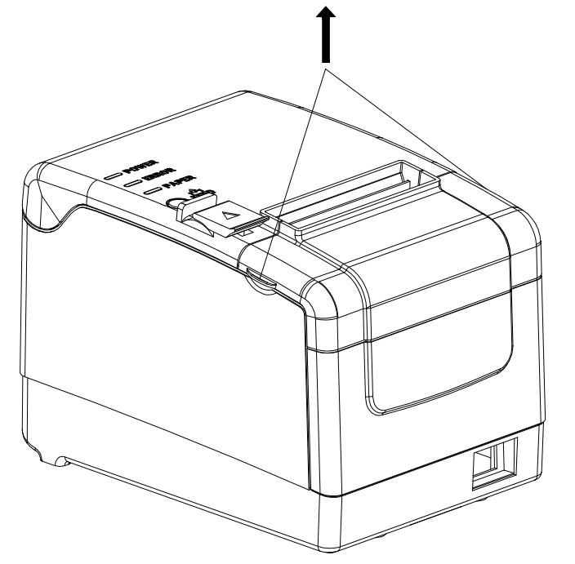
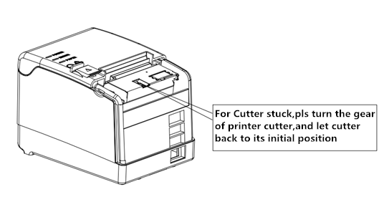Note: do not open cover by force, or may cause unrecoverable damage to the print head and the cutter.

Printer driver
80MM series thermal printer driver mode has two kinds, one is using the port for directly printing, the other is install driver in Windows system to print.
1.port direct drive
In this way, do not need to install the driver, only need to output the character (commands and data) directly to port, and to achieve character conversion printing by printer inner hard font library. Using port directly drive, make the print control more convenient.

If you use port direct drive mode, you need to use the print command set to control the printer's printing, 80MM series thermal printer has integrated the ESC/POS instruction set.

2.Install driver in windows system
Install driver stored in CD under windows system, you use the driver under the program and realize printing. In this way, it is Windows driver that turn the character into a graphic dot and realize printing.
Windows driver installation instructions, please see Step (1) -(6):

- Double click the driver setup ，click "ok"
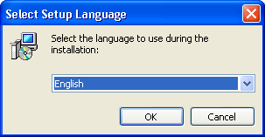
- Click the "next step"
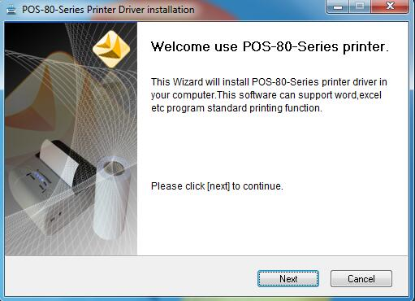

- Select "I accept this Agreement", click "next"
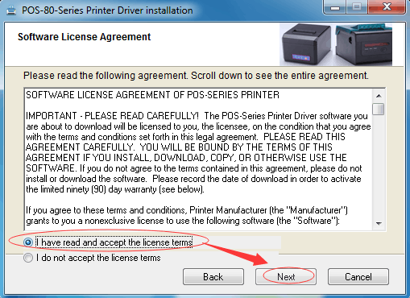
- Click "install"
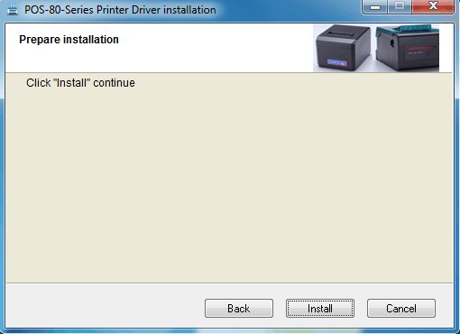
- Setup software will automatically identify the version of the Windows system, click "Next” 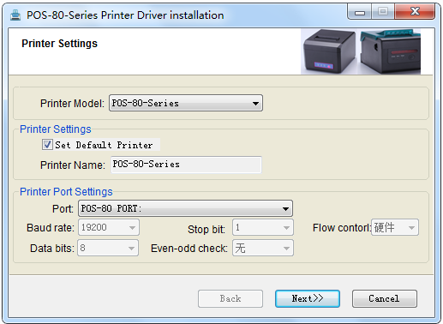
(6) Click "finish" to complete the driver installation. After this step completed, mean the driver have been installed successfully.
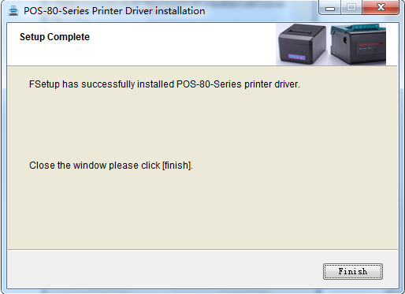

（7）For Ethernet printing, need to add the Ethernet port in your side. Open Driver POS-80MM-Series and right click it, choose the Printer Properties and add new Ethernet port. The Exact adding way show as following. (Only Printer with Ethernet port need to check following steps)
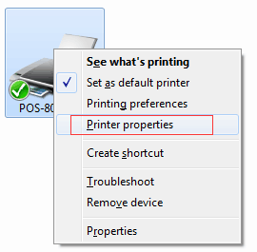
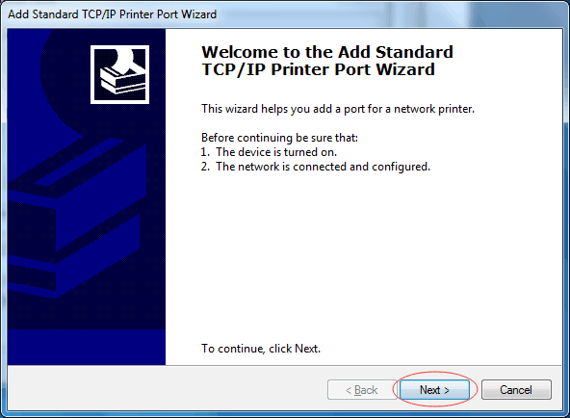
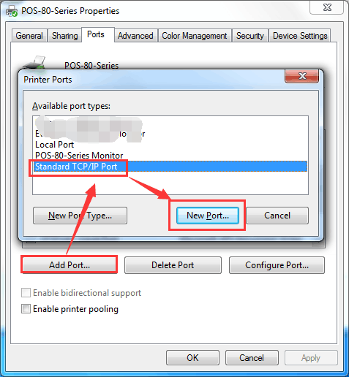
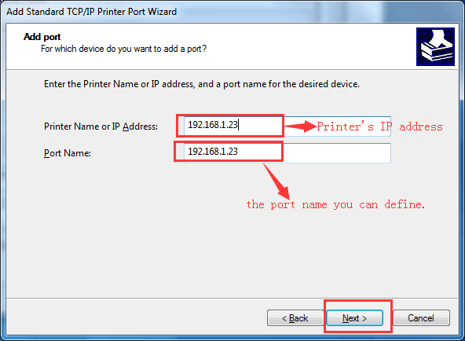
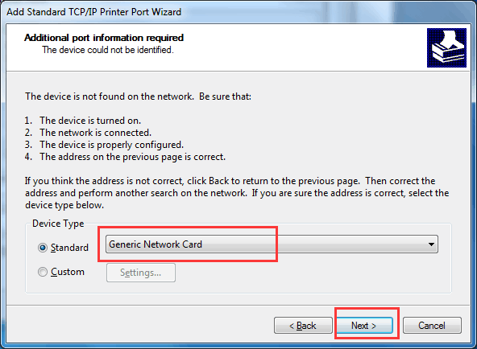
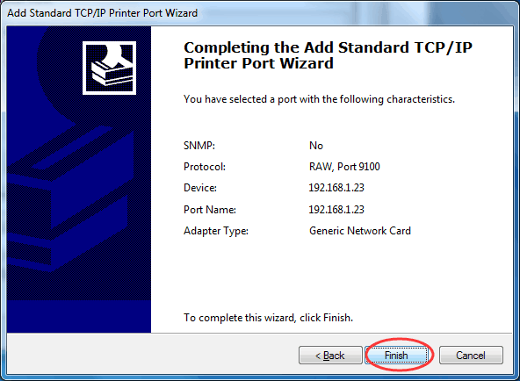
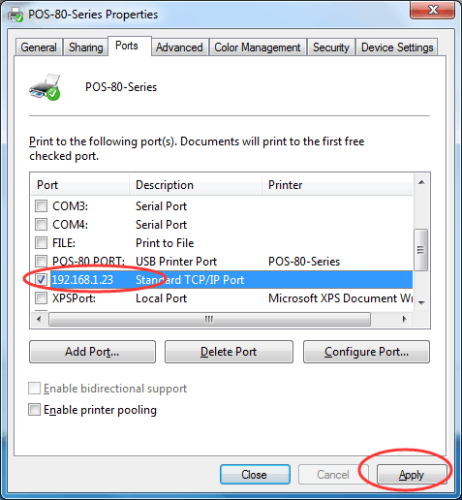

Printer Repair and maintenance
1. printer external and warehouse cleaning: please use a wet cloth gently wipe the printer surface and internal paper warehouse.
2. Printer core clean: printer core must be clean on time, especially the quality of printing is decline, cleaning methods are as follows: put cotton dipped in anhydrous alcohol and gently wipe the printer core ceramic parts as shown in the picture below until clean enough.
3.If find water inside printer, pleas immediately cut off power, and dry the printer naturally.
Failure Analysis:
Failure phenomenon | Failure cause | Solution
Printer paper light and Error light flashing at same time, and make a Di Di... beep sound | Printer lack of paper | Install paper correctly
Printer error light flashing and make a Di Di...beep sound | 1, The printer cutter problem. 2.The printer head is overheated  3. The cover not closed well | 1, Please follow the “Cutter stuck maintenance” schedule above to solve.  2, Open the cover and dissipate heat fully then go on printing.  3. Confirm Cover Closed well
When printing, only paper running but no print | Thermal paper install reverse | Please install the paper in a opposite direction
The printer print fuzzy | The print head not clean for a long time | Put cotton dipped in anhydrous alcohol and gently wipe the printer core ceramic parts until clean enough
The printer print fuzzy | The thermal paper is not good | Please choose high quality thermal paper
There is no response on printer | The power adaptor not connected | Please check power adaptor is connected well and power switch is on.
Printer can self-test, but cannot print online | Driver port selection error | Please select the correct print driver port based on the actual connection port
Printer serial port does not print or print garbled | Bit rate selection error | Please set COM baud rate according to the COM info on self-test page

