NBP4
Bluetooth Thermal Printer
Instructions

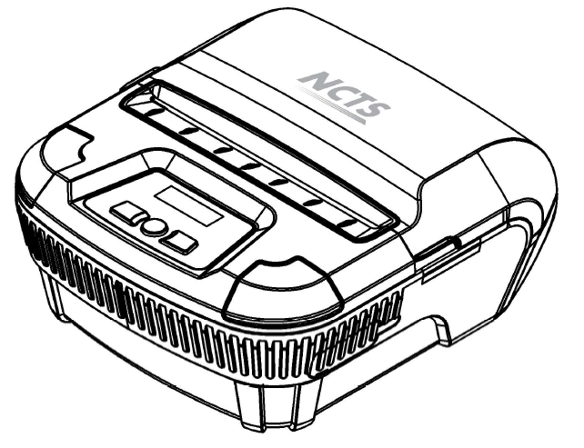
（Ver 1.0）

1

Content

Notice 3
Notice on Safety 3
Notice of Using 3
Notice of Storing . 3
Chapter1 Outer Appearance and Model No. 4
1.1 Outer Appearance 4
1.2 Model No. 5
Chapter2 Characteristic Capability 5
2.1 Printing Capability 5
2.2 Other Capability.. 6
Chapter3 Operation Method 6
3.1 Using Preparation 6
3.1.1 Battery Installation. 7
3.1.2 Paper Roll Installation 6
3.2 Basic Function Usage 7
3.2.1 Switch On . 7
3.2.2 Switch Off 7
3.2.3 Paper Feeding (Manual Feeding) 8
3.2.4 Self Test 8
3.2.5 Battery Charging 8
3.3 Printer Parameters Setting 9
3.4 Printer Interface Connection and Printing 9
3.4.1 USB Connection 9
3.4.2.Bluetooth Connection 10
3.4.3 Bluetooth Address Binding 10
3.5 Explanation of Indicator and Buzzer 10
Chapter4 Other Information . 11
4.1 Printer Developing Manual. 11
4.2 Description of Black Mark Pre-print 11

NOTICE

Please read this manual carefully before using the printer!

Notice of Safety

Be sure to use the specified battery and power supply provided by our company. Otherwise it may cause fire, explosion or damage printer, meanwhile, the battery also may be damaged.
Don’t put battery into the fire, don’t disassemble or heat the battery, don’t be short circuit, it may cause fire, explosion or damage printer, meanwhile, the battery also may be damaged.
If the printer would not be used for a long time, be sure to take off the battery, otherwise the battery may leak liquid which is corrosive liquid, if improper operation causes battery leak liquid, and it paste in the skin or clothes, please rinse it by clean water, if paste in the eyes, please rinse them thoroughly by clean water and see a doctor. Please do not open the paper case cover when it is printing or just when printing is finished, do not touch the printer head with hand or body, overheat may cause scald.

Notice of Using

Water or other liquid should not be spilled into the printer, also the printer should not be appeared in the rain, or else may cause printer damage. Please do not open the paper case cover when it is printing, otherwise the printer may work improperly. If printer is using USB connection to work, should not unplug the USB cable, or else some printing data may be lost. When printer is using USB connection to work, the distance of communication should be within 10 meters, otherwise the printer doesn’t print or prints rubbish codes. Too high（45℃）or too low（5℃） environment temperature and too high (85％) or too low (20％) environment humidity both effect the printing quality. The printer paper roll with poor quality or stored for too long time also may reduce the printing quality even damage the printer. Under the black mark detecting mode, the printer requires that the pre-printed black mark is accordant with the printing rule of black mark (please refer to details in Chapter 4.2), otherwise the black mark can not be detected correctly. Be sure to use up the power of the battery before charge up it,as it can ensure the using life of the battery.

Notice of Storing

The printer should be placed in such an environment that the temperature is between-40℃ and 70℃, and the relative humidity is between 10% and 95%. If the printer will be stored for a long time, please be sure to take out the battery, otherwise may damage the battery and printer.
Normal thermal paper receipt can’t be kept too long, if you need to keep the receipt for a long period, please choose long-term effective thermal paper. The thermal paper should be keep away from high temperature environment and point-blank sunshine, please store it where is away from light if it have been open.

Chapter 1 Outer Appearance and Model No.

1.1 Outer Appearance
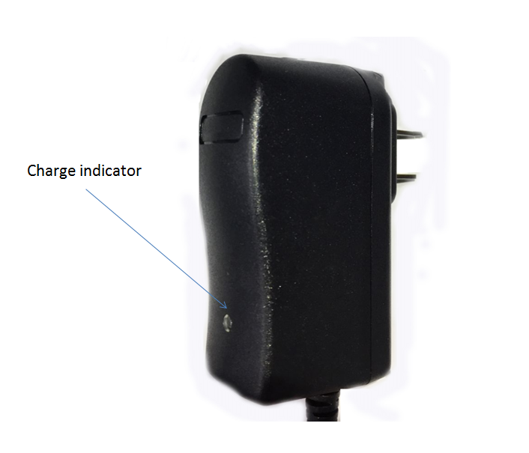
Power indicator or LCD
Setting button
Power button
FEED button
Mini USB plug socket
and power charging port

1.2 Model No.

NBP4 Support USB and Bluetooth Interface

Chapter 2 Characteristic Specification

2.1 Printing Specification

Printing Method | Thermal Line
Resolution | 8 dots/mm, 576 dots/line
Effective Printing Width | 72mm
Printing Speed | 80mm/s
Character Set | ASCII,GB18030(Chinese), BIG5
Print Font | ANK: 12 x 24 Chinese: 24 x 24
Self-defined Character | Yes
Barcodes | 1D:UPC-A, UPC-E, EAN-13, EAN-8,CODE39,  ITF25 ,CODABAR, CODE93, CODE128  2D:PDF417, QR code, DATA Matrix
Graphic | Support bitmap downloading
SDK | Symbian/Windows Mobile/Android/ios
Driver | Windows XP/Vista/7/8/8.1/10,
Paper End Sensor | Yes
Black Mark Location | Yes
Auto Sleeping | Yes
Buzzer | Yes
Interface | USB+Bluetooth
Battery | 2200mAh/7.4V
Charger | DC 8.4V/1A
TPH | 50km
Paper Type | Thermal paper
Paper Width | 79.5± 0.5mm
Paper Thickness | 0.06 to 0.08mm
Paper Roll Diameter | 50mm(Max.)
Paper Supply Method | Drop-in Easy loading
Paper Cutting Method | Manual
Operating Temp/Humidity | 0-50°C/10%-80%
Storage Temp/Humidity | -20-60°C / 10%-90%
Dimension (LxWxH) | 125*114*58mm
Weight | 0.33kg（Net weight）/0.73kg（Including packing）

2.2 Other Specification

● Paper Loading Method: drop-in easy loading ( please refer to details in 3.1.2 Paper Roll Installation).

● Black Mark Location: available(details please see 4.2
pre-printing black mark manual).

● Paper End Detection: when paper is out,LCD screen missing paper,The buzzer rings when it is printing, and it will stop printing.

● Printing Control Command: ESC/POS compatible command set
(refer to<NBP4 Printer Developer Manual >).

● Power Supply: 7.4VDC/2200mAh rechargeable polymer lithium battery.

● Power Alarm: when the battery is low, the battery indicator blinks(or LCD display power low)

● Battery Charging: quick charging ,it will be charged full about 3 hours;
● Battery Duration: under25% printing density ,at least 180 meters, the standby time is over 100 hours.

These parameters are just for reference, long term usage will cause the capacity decline, and can not ensure the time of printing.

Chapter 3 Operation Method

3.1 Using Preparation

3.1.1 Battery Installation

1. Put the battery into the battery slot.
2. Install the battery cover.
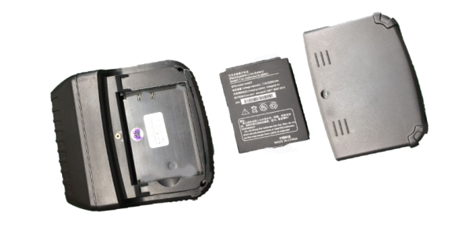
3.1.2 Paper Roll Installation

1. Hold both sides of the paper case cover, and open it.
2. Pay attention to use paper that effective printing side is outside in the printing paper face when you enchase the new paper roll.
3. Pull out a part of paper and put them in the middle of the paper out orifice.
4. Shut down paper case cover and cut off the redundant paper
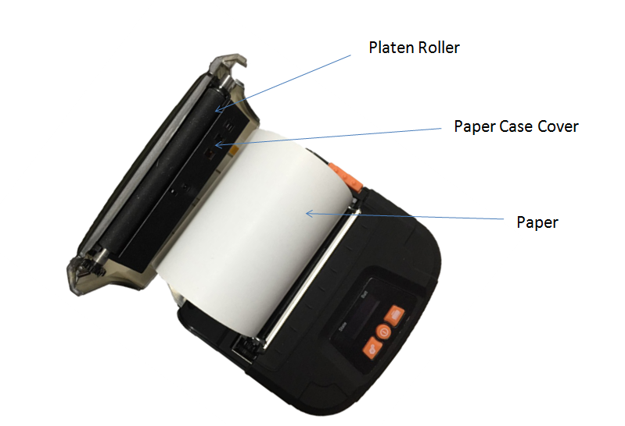

3.2Basic function usage

3.2.1 Switch On

Press【POWER】button, the power indicator is on（or LCD on）, about 1 second later you will hear prompt tone. The printer will turn into work mode.

3.2.2 Switch Off

Under status of switch on ,the printer will send out the prompt tone after pressed the【POWER】button for 1 second, the power indicator go out （or LCD go out）, then loosen the【POWER】button, the printer is off.

3.2.3 Paper Feeding (Manual Feeding)

Under the normal work status, press 【FEED】 button, the paper feeding begins, and stop when loosen 【FEED】 button. When the printer works in black mark mode, press【FEED】button, the printer begins to feed paper and stops over the position of black mark. If the paper is not the black mark paper, the printer stops automatically after feeds paper for 30cm.

3.2.4 Self-Test

After receiving the printer, user can check its current setting and status at anytime. Self-test way is as below: Power off, then hold down the 【FEED】 button and press the power button at the same time. Then loosen the power button when you hear prompt tone, the current setting and status will be printed out.

3.2.5 Battery Charging

The battery will run out after a period of usage. When it nearly runs out, if the printer is used to print data, printer will give a alarm through the battery blue indicator flashing; if the printer is sleeping, printer will turn off automatically. At this time, user needs to charge up the battery
The charging method is as following: connecting the adapter to the power socket with 220V, 50HZ, then plug the power charging plug to the power socket of the printer, so the power charging begins. During the course of power charging, the charging indicator 【CHARGE】 goes red, and【CHARGE】turns to green when the charging is full. It takes about 3 hours to charge up the battery. Using the printer during the course of charging power will make the charging time go longer. It shows the failure if the charging indicator【CHARGE】goes green and red during the course of charging. Such as faulty installation of battery, faulty contact of battery or internal temperature of battery is too high or too low.

3.3 Printer Parameters Setting

Users can set more parameters by using the specified〈NBP4 Setting Tools〉software through computer. The setting includes: language、font、printing density、default code page、bluetooth device name and password (onlyNBP4BT) etc. The setting method please refer to the <NBP4Setting Tools Software Help>, offered with the software together.

3.4 Printer Interface Connection and Printing

3.4.1 USB Connection

The NBP4 printer of standard accessories includes Mini USB cable which connects printer. The USB type belongs to the slave device type.

3.4.2 Bluetooth Connection

Handheld device, laptop and other information terminal devices with Bluetooth can drive NBP4 to print by the Bluetooth interface. NBP4 portable printer is compatible with Bluetooth2.0 standard. Power class is CLASS 2, effective communication distance is 10meters. The Bluetooth of the printer belongs to the slave device. The initial name of the printer is NBP4Printer, the initial password is ‘1234’; users can change the printer name and password by using<NBP4 Setting Tools> software. Please see the details in help file of <NBP4 Setting Tools>.

Before working, NBP4 Portable Thermal Printer need to be pairing with primary device，matching begins with the host device. Usual matching course is as below:

1. Switch on printer;

2. Host device searches for the outer Bluetooth device;

3. If there are other Bluetooth devices, please select NBP4 BT Printer;

4. Enter the password ‘1234’;

5. Pairing finished.

Please see details in primary device Bluetooth function instruction for reference.

Notice:

1, When pairing, please make NBP4 BT switch on.

2. Once NBP4 has paired with the host successful, it can’t be paired with other Bluetooth device until it unconnected with the host.

3, The power indicator flashing after paired successful.

3.4.3 Function of Bluetooth Address Binding

Bluetooth Binding: once the printer remembers the device’s address, it only can connect with the first device and can’t connect with others. So in this case, if the printer needs to connect with other devices, user can delete the remembered address or set the mode is not binding.
No binding: in this case, the printer can be searched or paired by other devices. So when the printer needs to connect with a fixed device, it would be better to bind address. Please see the details in help file of<NBP4 Setting Tools>

3.5 Indicator and Buzzer

There are four indicators, they are red and blue【CHARGE】light, red【ERROR】light, blue 【BATTERY】indicator and green【POWER】indicator. The meanings of each indicators are as below:

【POWER】indicator

Light constant on: printer is on, Bluetooth is with disconnect status

Light flashing: printer is on, Bluetooth is with connection status

【CHARGE】indicator

Green light constant on: charging is completed;

Red light constant on: in charging;

Green and red lights on: there are some mistakes, please check whether the battery should be good contact or not, and the temperature is normal or not.

【ERROR】indicator

Constant on lighting: printer out of paper

ERROR Light: printer has mistakes. Different types of mistake, different ways of flashing

【BATTERY】indicator

The battery indicator composed by three parts in order to show the battery status.

Three parts light on: battery is high

Two parts light on: battery is medium

One part light on: battery is low

Minimum part flashing: battery is extremely low, it must be charged

Three parts flashing at same time: power supply should be over voltage (external power supply without battery)

There is also a buzzer to indicate various status of the printer. The meanings are as below:

One low one high: power on;

One high one low: power off;

Circulation continuous two lows: printer at mistakes status

Chapter 4 Other Information
4.1 Command Programming Manual

<NBP4 Technical Manual> is a technical manual for engineer to develop printer utility, and users can claim our company for it. This manual including the technical description of hardware interface ( Bluetooth, USB interface ), technical documentation of printing control command set, and others such as how to print black mark and locate by it.
4.2 Description of Black Mark Pre-print
If user use pre-print black mark to locate the receipt, please be sure to abide by the following black mark pre-print regulation when print the black mark paper, if not ,it will cause that the printer can not identify the black mark.

The black mark pre-print regulations are as below:

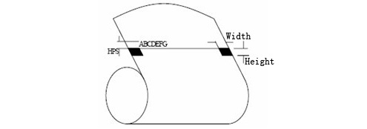
Printing Position: As the picture above, the black mark should be printed on the right or left edge of the side of words.
Width range: width≥7mm
Height range: 4mm≤height≤6mm
Reflectivity of infrared ray : <10% (infrared ray reflectivity of other parts of the black mark paper is>65%)
HPS: it is the distance between edges of black mark and loading position.
4.5mm≤Hps≤6.5mm


