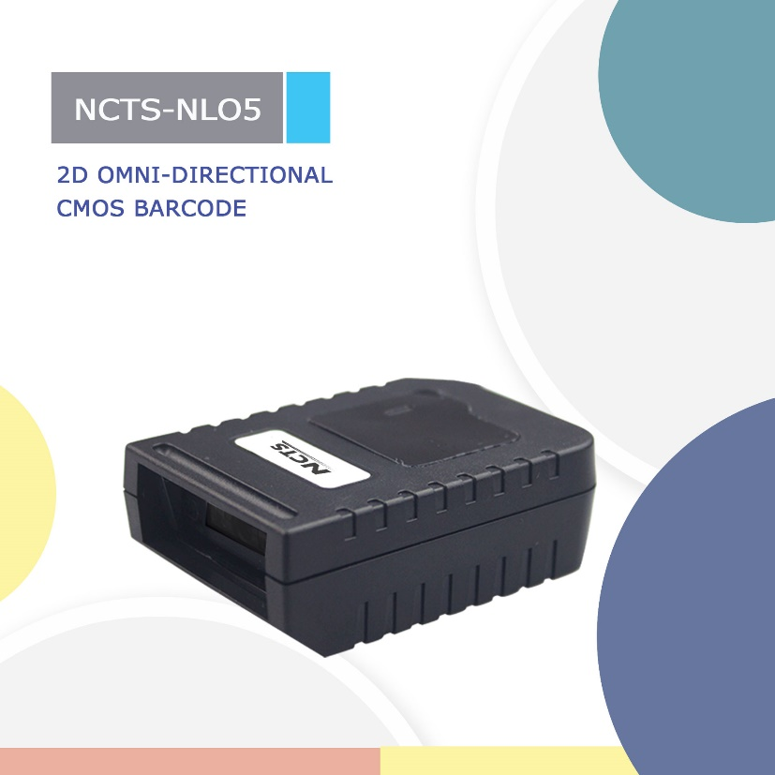

NCTS-NLO5

(2D CMOS Fix-mounted Barcode Scanner)
Technical Parameters
Electrical Characteristics
Interface | RS-232/USB HID KEYBOARD/USB VCP
Voltage requirement | 5VDC±10%
Current consumption | Max:280mA
Optical Characteristics
Photo sensor | CMOS array sensor
SENSOR RESOLUTION | 648X488 pixels
Light source | white LED*1
Aim light source | Red Bar led
Performance Characteristics
Decode angle | Pitch angle:±65°  Skew angle:±60°  Tilt angle:±180°
Min resolution | 1D:5mil(0.127)
Curvature | R≥15 mm (EAN8)，R≥20 mm (EAN13) （resolution=0.26mm，PCS=0.9）
Field of View | 34°(H),26°(V)
Identification | 1D：UPC/EAN,Code 128, Code 39,  Code 93, Code 11, Matrix 2 of 5, Interleaved 2 of 5, Codabar, MSI，GS1 Databar  2D：QR, PDF417，Data Matrix
Physical Characteristics
Dimensions | 68 mm x 48 mm x24mm(L*W*H)
Weight | USB/USB VCP：118g  RS-232:147g
Environmental Characteristics
Temp | 0° to 40°C / 32°to 104°F((operation) )  -40°-to 70°C /-40°to 158°F(storage)orage)
Humidity | 5 - 90% (operation) ) 5 - 90% (storage)
Ambient Light: | fluorescent light 4000 lx max , direct sun light 80,000 lx max ,white light 4000 lx max
Regulatory
Electrical Safety | UL 60950，EN/IEC 60950d ed.
EMI/RFI | FCC Part 15 Class B,EN 55024/CISPR 22
Environmental | RoHS
Depth of field
Symbology | Resolution(mm) | Depth of field
Code39 | 5.0 mil | 40mm--90mm
Code 39 | 15.0mil | 40mm—250mm
100% UPCA | 15.0mil | 40mm--250mm
Code 93 | 10.0mil | 40mm--210mm

