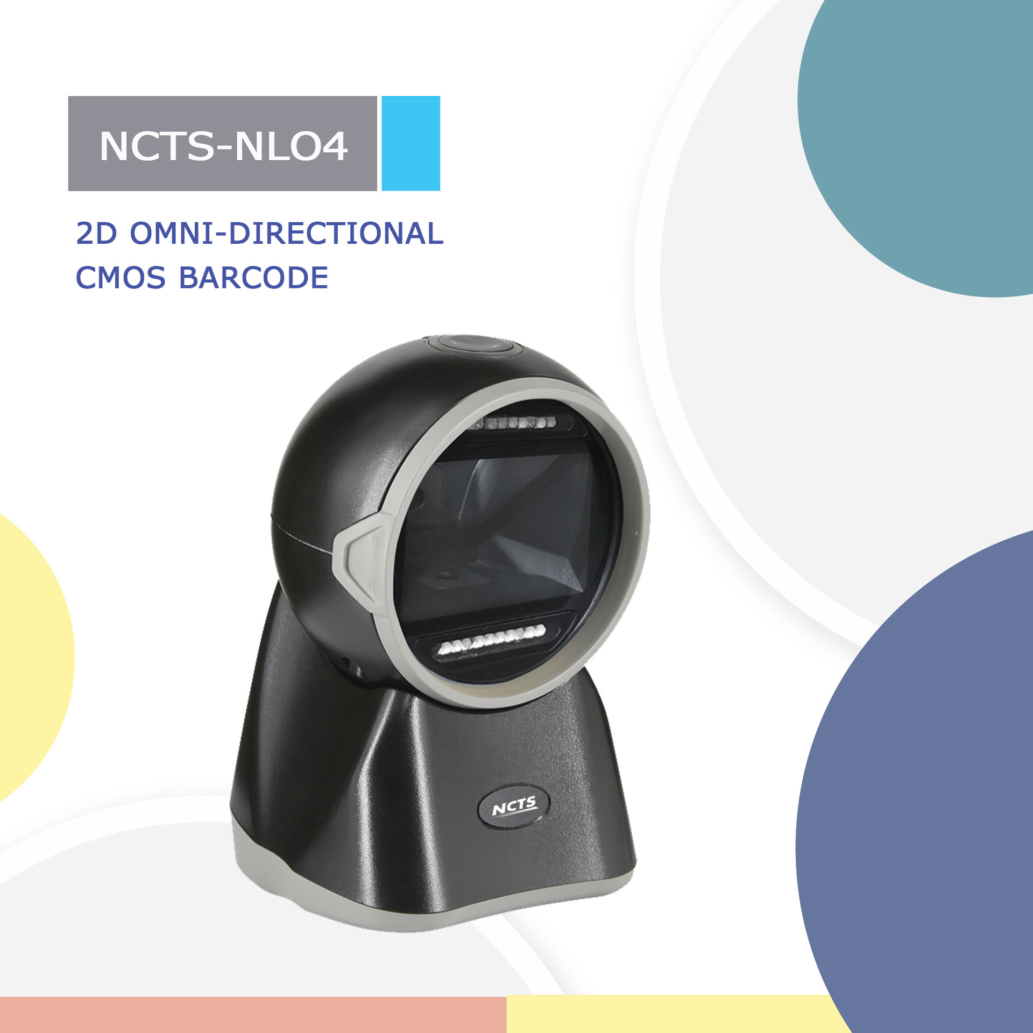

NCTS-NLO4

Version:V1.0
2D Barcode Image Scanner
Technical Specifications
Electrical Characteristics
Interface Supported | RS-232/USB HID KEYBOARD/USB VCP
Input Voltage | DC 5V±10%
Current | Max:200mA
Optical Characteristics
Image Sensor | CMOS Array Sensor
Sensor Resolution | 1280 X 800 Pixels
Light Source | RED LED
Performance Characteristics
Field of View | 58°(H),45°(V)
Min Resolution | 1D：0.076mm/3mil（PCS 0.9）  2D：0.152mm/7mil（PCS 0.9）
Min .PCS value | 〉30% UPC/EAN 13（13mil）
Language | Multiple Languages
Data Edition | Support for custom data output
Decode Capability | 1D : UPC-A / UPC-E / EAN-8 / EAN-13, ISBN, Code 39, Code 93, Code 128, Code 32, Codabar, MSI Plessey, Interleaved 2 of 5, Pharmacode ,  2D : PDF417, MicroPDF417, Data Matrix, QR Code, Micro QR Code, DotCode
Physical Characteristics
Dimensions | 100mm*95mm*158mm(L*W*H)
Weight | 265g
Indicator | Beeper, LED
Environmental Characteristics
Temperature | 0°∽50°C (operation)  -10°∽60°C (storage)
Humidity | 20 - 85% (operation) ) 20 - 85% (storage)
Shock Drop Test | 1.5m drop onto concrete surface

