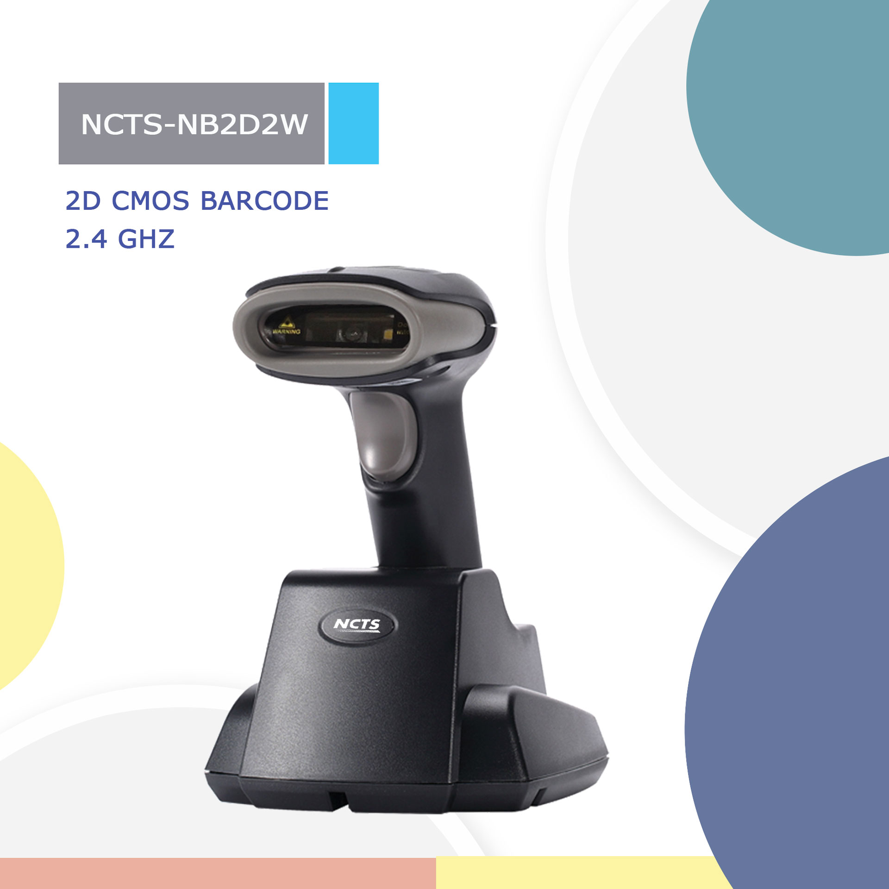
NCTS-NB2D2W
（2D CMOS Wireless RF433 Handheld Barcode Scanner）

Technical parameters
Wireless specifications
Communication |  | 433
Communication frequency |  | 433 to 440MHz
Transmission range |  | 100M（In empty area 80m-100m ）-real time mode  No limitation --Cache mode
Data rate |  | 10kbps
Memory |  | 100,000@13Byte barcode
Battery capacity |  | 2000mAh (Lithium battery)
Charging time |  | 6H
The life time of the full charge |  | 6h（continuous reading situation）  12h（Manual reading situation）  More than 15 days（Stand-by time）
Communication mode |  | Read-time mode/Inventory mode／Cache mode
Electrical Characteristics
Interface | USB HID KEYBOARD/USB VCP
Voltage requirement | 5VDC±10%
Current consumption | Max:120mA
Optical Characteristics
Photo sensor | CMOS array sensor
SENSOR RESOLUTION | 648×488 pixels
Light source | 5600K white LED
Aim light source | Red Bar led
Performance Characteristics
Decode angle | Pitch angle:±55°  Skew angle:±55°  Tilt angle:±180°
Min resolution | 1D:5mil  2D:9mil
Min.PCS value | 〉30%UPC/EAN 13（13mil）
Field of View | 40°(H),30°(V)
Identification | 1D: UPC-A,UPC-E,EAN-8,EAN-13,Code 39,Code 128,Interleaved 2 of 5. Codabar, Code 93  2D: PDF417,MicroPDF417,Data Matrix,QR Code,Aztec
Physical Characteristics
Dimension | Scanner：70mm*95mm*168mm(L*W*H)
Environmental Characteristics
Temp | 0°to 50°C / 32°to 122°F((operation) ) -40°- 80°C /-40°to 176°F(storage)
Humidity | 5 - 95% (operation) ) 5 - 95% (storage)
Shock drop test | 1.5m drop onto concrete surface
Ambient Light: | 0-86,000LUX
Regulatory
Electrical Safety | UL 60950,EN/IEC 60950
EMI/RFI | FCC Part 15 Class B,EN 55024/CISPR 22
Environmental | RoHS

Depth of field
Symbology | Min depth of filed | Max depth of filed
5mil code39 | 30mm | 80mm
UPCA 13mil: | 50mm | 210mm

