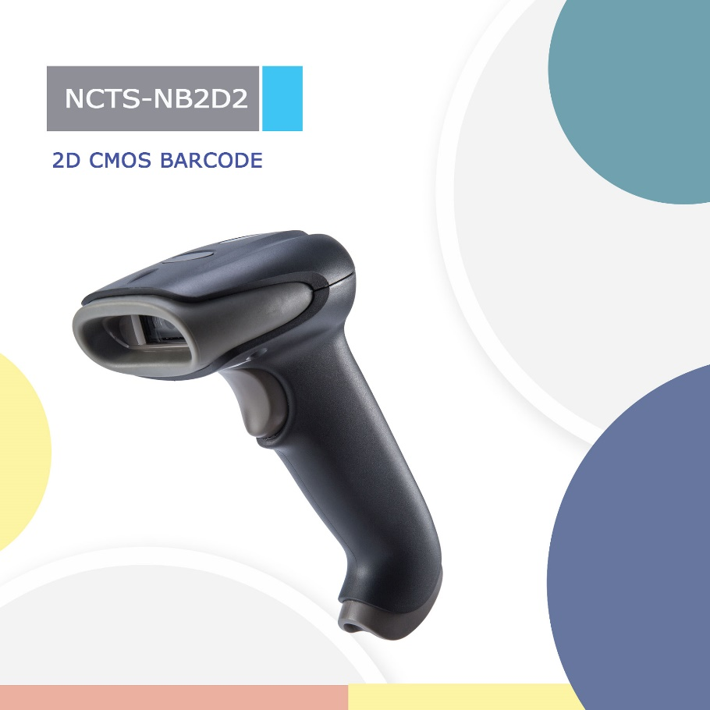

NCTS-NB2D2
(2D CMOS Wire Handheld Barcode Scanner)

Technical Specifications
Electrical Characteristics
Interface Supported | RS-232/USB HID KEYBOARD
Input Voltage | DC 5V±10%
Current | Max::190mA  Dormant current：48mA
Optical Characteristics
Image Sensor | CMOS Array Sensor
Sensor Resolution | 640x480 Pixels
Light Source | White LED
Aim Light Source | Red Bar LED
Performance Characteristics
Scanning Angle | Pitch angle:±60°;Skew angle:±40°;Tilt angle:±180°
Field of View | 66°(H),50°(V)
Min Resolution | 1D：0.127mm/5mil（PCS 0.9）  2D：0.202mm/8mil（PCS 0.9）
Min .PCS value | 〉20%UPC/EAN 13（13mil）
Language | Multiple Languages
Data Edition | Support for custom data output
Decode Capability | 1D : UPC-A，UPC-E，UPC-E1，EAN-8，EAN-13，EAN-14，EAN-128，UCC128， ISBN/ISSN， CODE11，CODE32，CODE39，CODE39 Full ASCII，CODE93，CODE128，  Crossing 25 Codes, Industrial 25 Codes, Matrix 25 Codes,  China Postal Code，UK/Plessey，GS1

 | 2D: QR code，PDF417，Data matrix
Physical Characteristics
Dimensions | 90mm*67mm*168mm(L*W*H)
Weight | 120g(not included cable)
Indicator | Beeper, LED
Environmental Characteristics
Temperature | -20°- 65°C (operation) ， -30°- 70°C (storage)
Humidity | 5 - 90% (operation) ；5 - 90% (storage)5
Ambient Light: | Up to 80,000 lx
Shock Drop Test | 1.5m drop onto concrete surface
Decoding Depth of Field
Symbology | Resolution | Barcode  number | Barcode width | Nearest | Farthest
Code 128 | 5mil | 20 | 4.3x1.5cm | 4cm | 8cm
Code 128 | 15mil | 7 | 4.3x1.5cm | 7cm | 32cm
Code 39 | 6.67mil | 16 | 4.4x1.5cm | 8.5cm | 11cm
Code 39 | 20mil | 4 | 4.3x1.5cm | 7cm | 37cm
EAN-13 | 13..34mil | 13 | 4.2x1.5cm | 6cm | 22cm
QR code | 20mil | 120 | 2x2cm | 4.5cm | 22cm
Data Matrix | 6.67mil | 60 | 0.5x0.5cm | 3cm | 11cm
Screen QR Code |  | 18 | 2.1x2.1cm | 3cm | 41cm
Screen QR Code |  | 18 | 3.7x3.7cm | 10cm | 78cm

