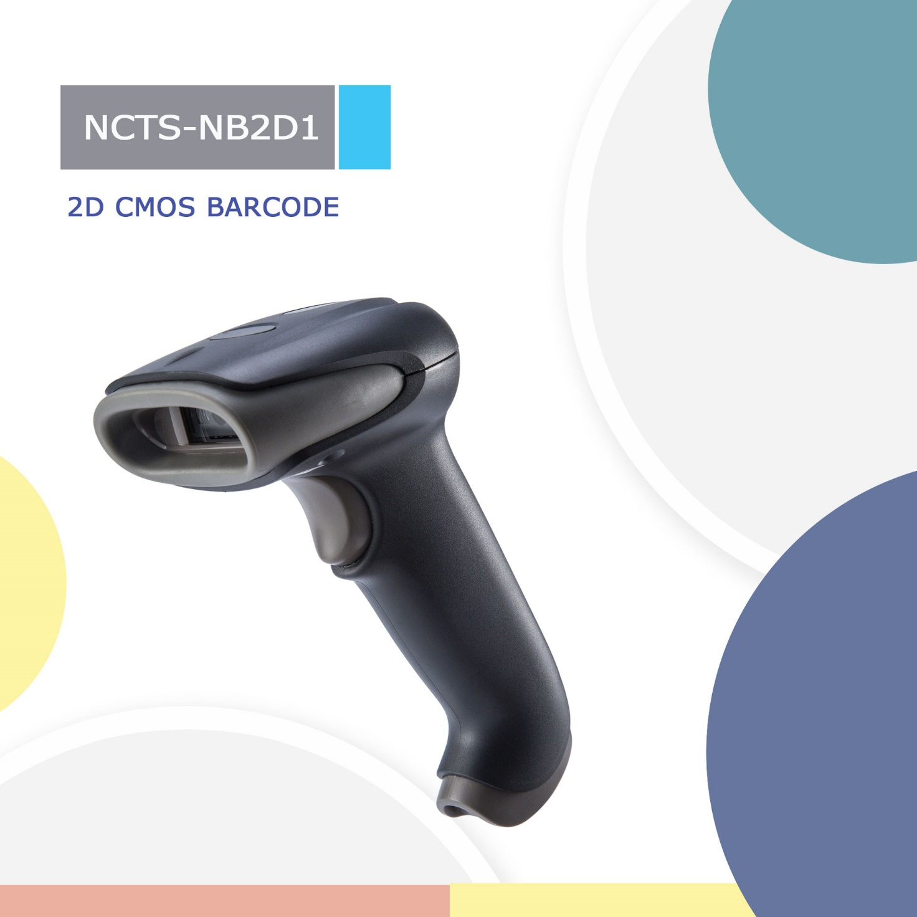

NCTS-NB2D1
(2D CMOS Handheld Barcode Scanner connect with Android phone)

Technical Parameters
Electrical Characteristics
Interface | Micro USB
Voltage requirement | 5VDC±5%
Current consumption | Max：180mA
Optical Characteristics
Photo sensor | CMOS array sensor
SENSOR RESOLUTION | 648×480 pixels
Light source | 5600K white LED
Aim light source | Red Bar LED
Performance Characteristics
Decode angle | Pitch angle:±55°  Skew angle:±55°  Tilt angle:±180°
Min Resolution | 1D:5mil  2D:9mil
Min.PCS value | 〉30%UPC/EAN 13（13mil）
Field of View | 40°（H）x 30°（V）
Identification | 1D: UPC-A,UPC-E,EAN-8,EAN-13,Code 39,Code 128,Interleaved 2 of 5. Codabar  2D: PDF417,MicroPDF417,Data Matrix,QR Code.
Physical Characteristics
Dimensions | 90mm*95mm*188mm(L*W*H)
Weight | 128g
Environmental Characteristics
Temp | 0°to 50°C / 32°to 122°F((operation)  -40°- 80°C /-40°to 176°F(storage)
Humidity | 5 - 95% (operation) ) 5 - 95% (storage)
Shock drop test | 1.5m drop onto concrete surface
Ambient Light: | 0-86，000KUX

Depth Of Filed
Symbology | Min depth of filed | Max depth of filed
5mil code39 | 30mm | 80mm
UPCA 13mil： | 50mm | 210mm

