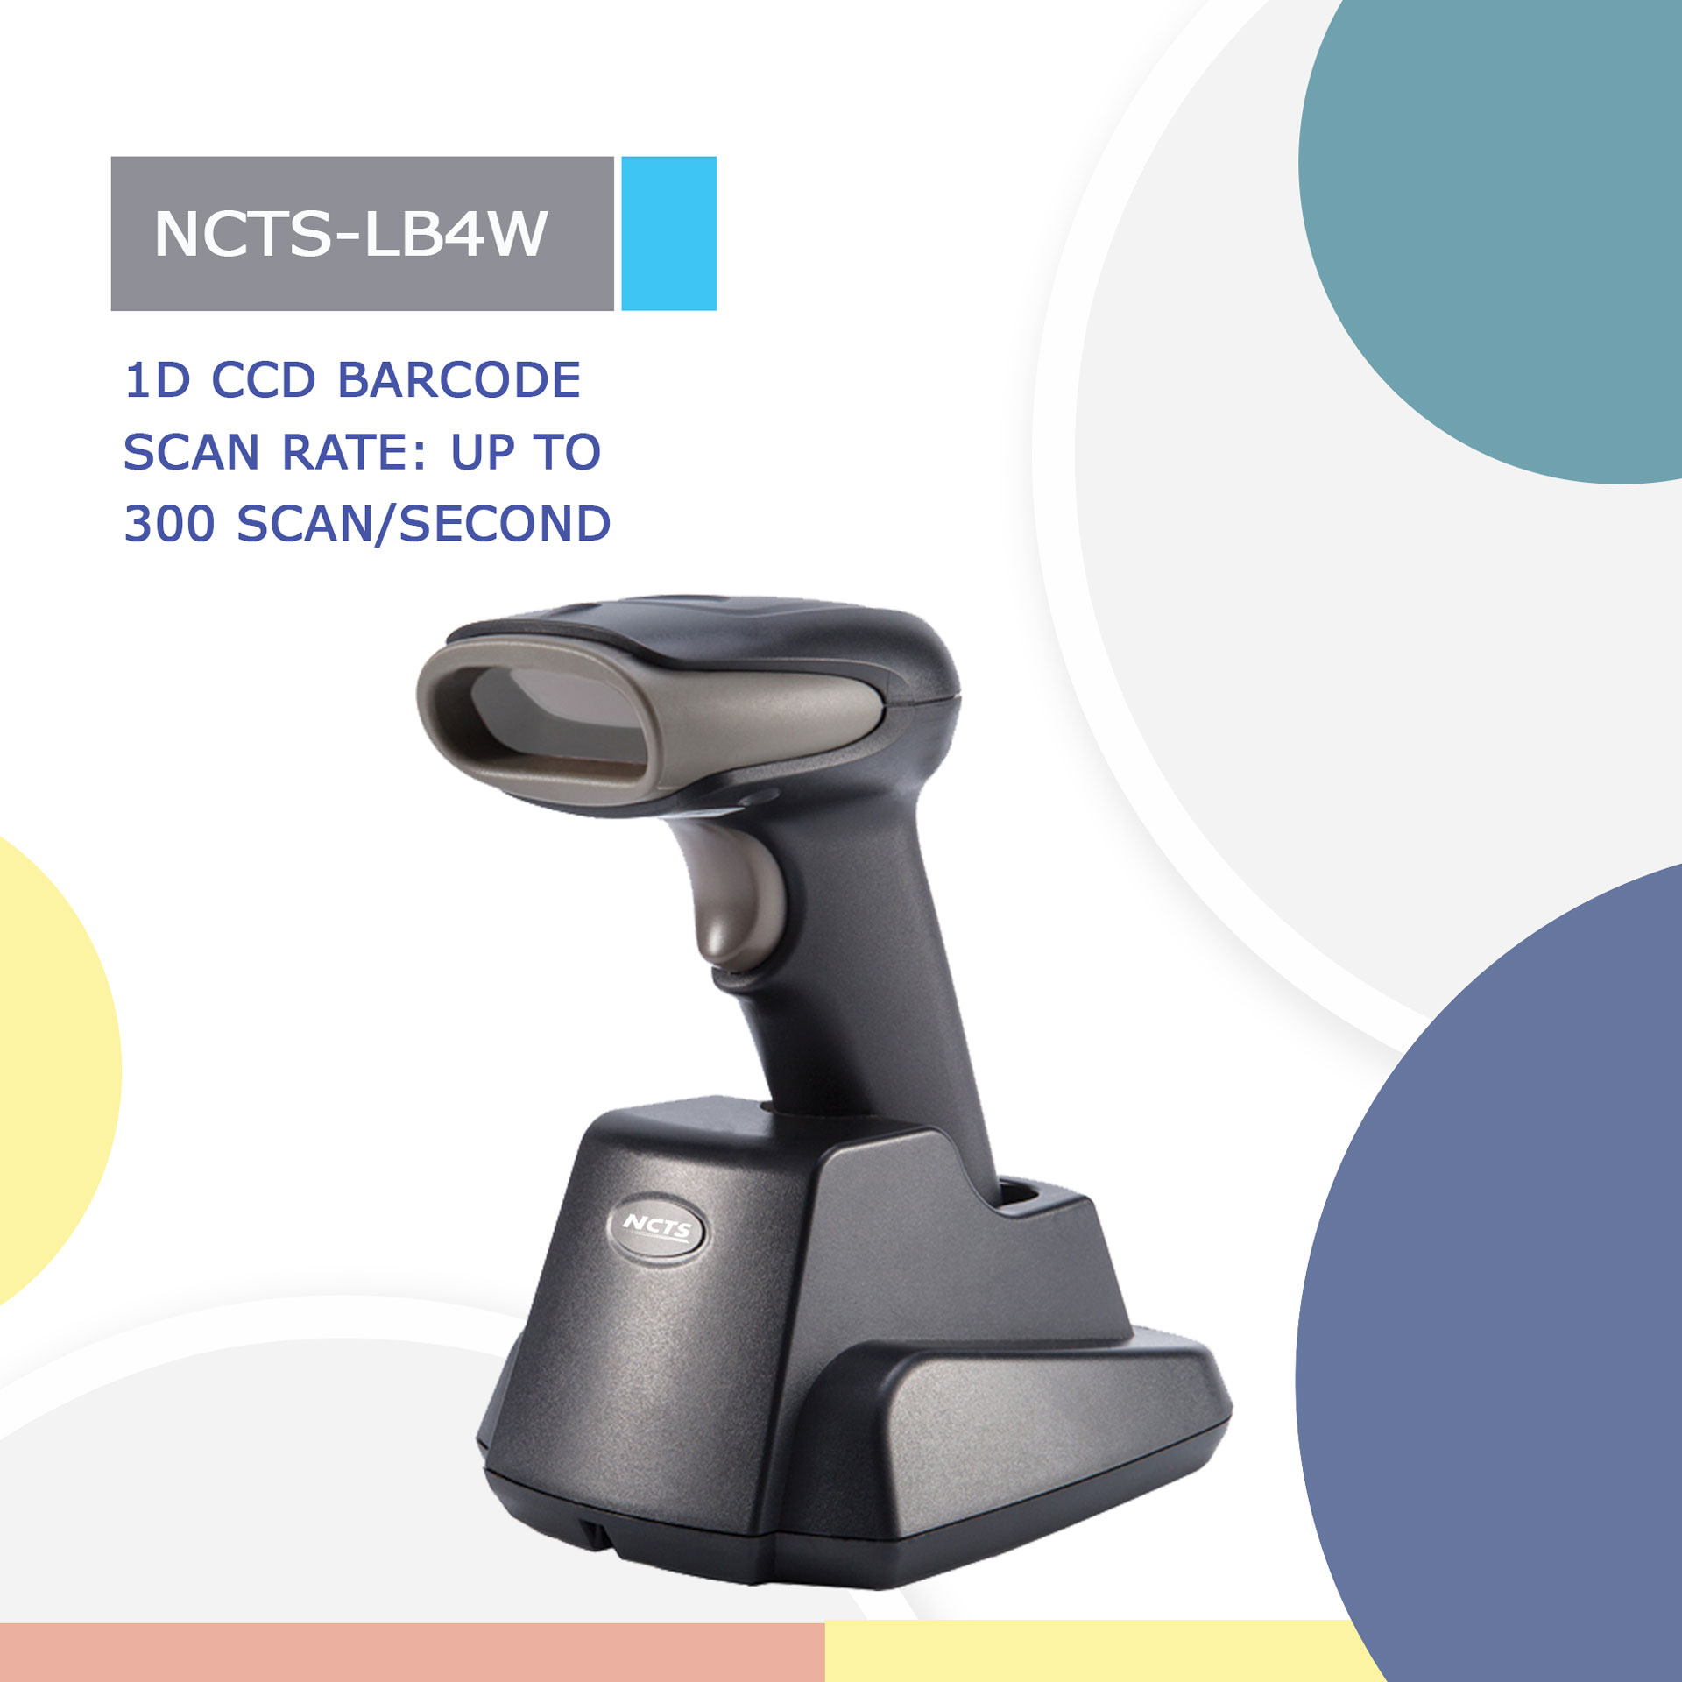
NCTS-LB4W
(1D CCD RF433 Wireless Hand held Bar code Scanner)

Technical Parameters
Wireless Specifications
Communications |  | 433
Communication frequency |  | 433-440MHz
Transmission range |  | ≤100M（In empty area 100M ）
Data rate |  | 10kbps
Memory |  | 100，000@13Byte barcode
Battery capacity |  | 2000mAh (Lithium battery)
Charging time |  | 6H
The life time of the full charge |  | 6h（continuous reading situation）  12h（Manual reading situation）  More than 15 days（Stand-by time）
Communication mode |  | Read-time mode/Inventory mode／Cache mode
Electrical Characteristics
Interface | RS-232/USB HID KEYBOARD/USB VCP/RS-485
Voltage requirement | DC 5V±10%
Current consumption | Max:138mA
Optical Characteristics
Photo sensor | CCD linear sensor
Sensor Resolution | 2500pix
Light source | 632nm red LED
Performance Characteristics
Scan Rate: | 350±50(scan/second) 350±50 (scans/second)
Decode angle | Pitch angle:±30°  Skew angle:±75°  Tilt angle:±45°
Min resolution | 0.115mm／4.5mil（PCS 0.9）
Min.PCS value | 〉20%UPC/EAN 13（13mil）
Language | multiple languages
Identification | EAN13，EAN8，UPC A，UPC E，CODABAR（NW-7），CODE 39，CODE 93，INTERLEAVED 2OF5，STANDARD 2OF5，MATRIX 2OF5，CODE 128，EAN/UCC 128，CODE 11，CHINESE POST
Curvature | R≥15 mm (EAN8)，R≥20 mm (EAN13) （resolution=0.26mm，PCS=0.9）
Physical Characteristics
Dimensions | Scanner：70mm*95mm*168mm(L*W*H)  Base：145mm*112mm*74mm(L*W*H)
Weight | scanner：186g  Receiver：188g
Environmental Characteristics
Temp | -20°-65°C / -4°To 149°F((operation) ) -30°- 70°C /-22°To 158°F(storage)
Humidity | 5 - 90% (operation) )  5 - 90% (storage)
Ambient Light | fluorescent light 4000 lx max , direct sun light 80,000 lx max ,white light 4000 lx max
Shock drop test | 1.5m drop onto concrete surface
Regulatory
Electrical Safety | UL 60950，EN/IEC 60950
EMI/RFI | FCC Part 15 Class B,EN 55024/CISPR 22
Environmenta | RoHS

Depth Of File
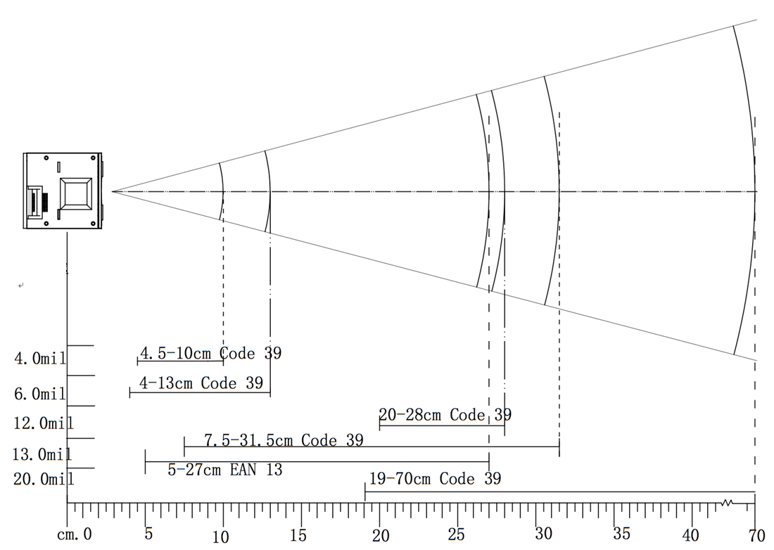

Symbology | Resolution  mm(mil) | Depths of Field | Digits
Code 39 | 0.101(4mil) | 4.5-10cm | 6
Code 39 | 0.152(6mil) | 4-13cm | 12
Code 39 | 0.30(12mil) | 20-28cm | 13
Code 39 | 0.33(13mil) | 7.5-31.5cm | 12
EAN 13 | 0.33(13mil) | 5-27cm | 13
Code 39 | 0.86(34mil) | 19-70cm | 10

