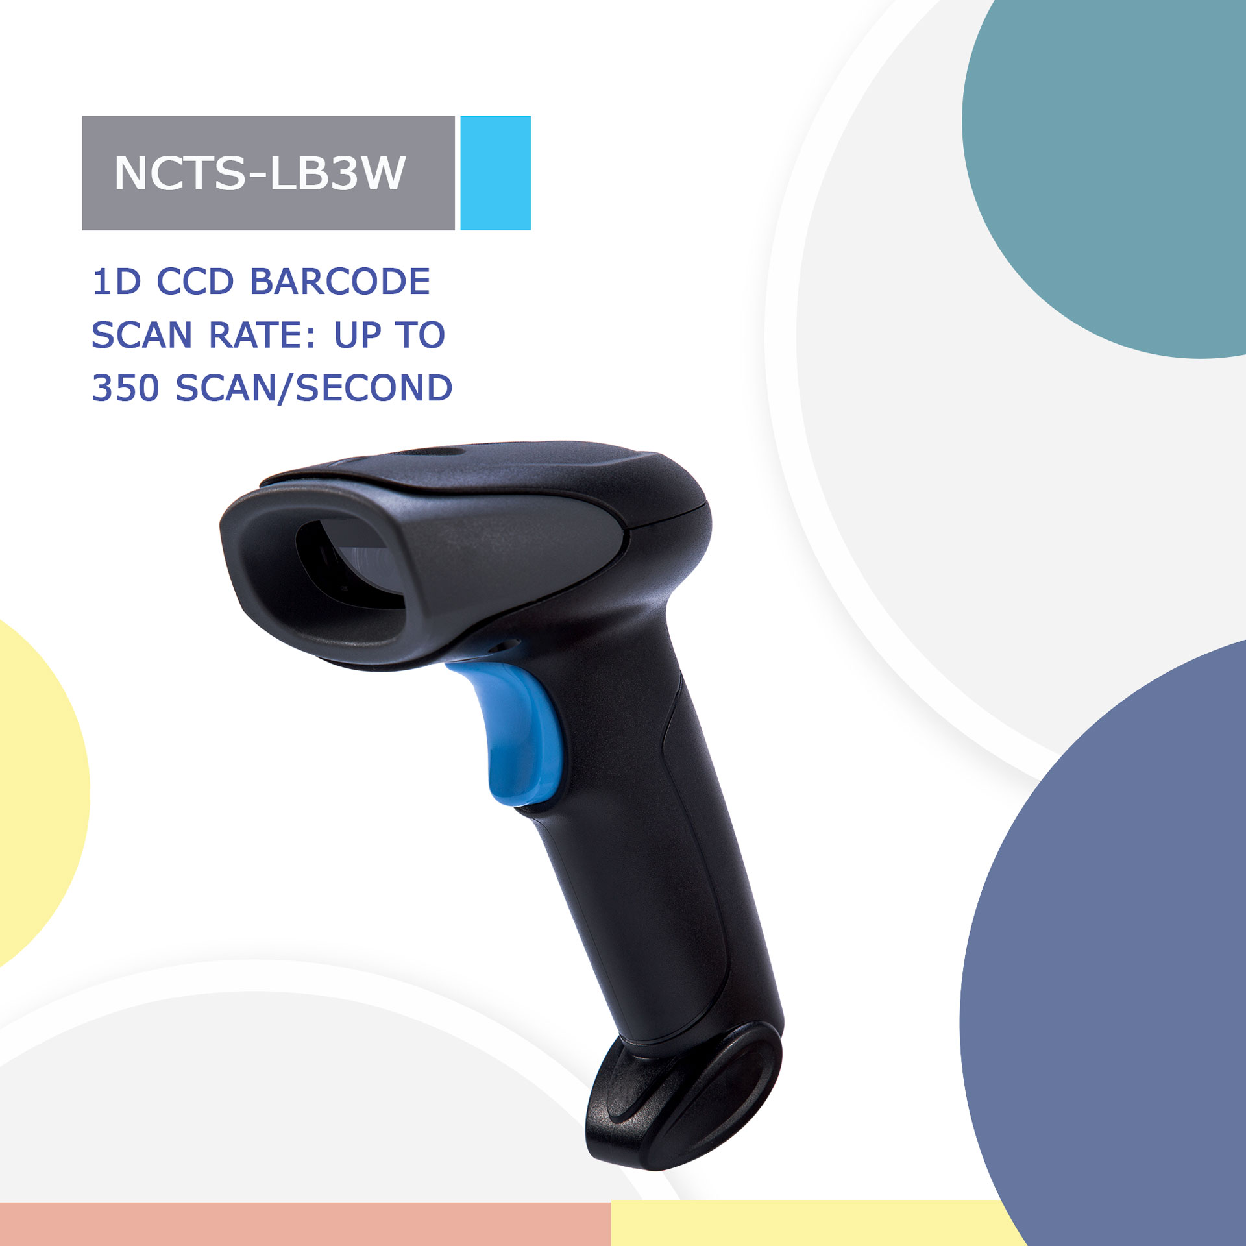
NCTS-LB3W
(1D CCD Wireless 2.4G Handheld Barcode Scanner)

Technical Parameters
Wireless specifications
Communications | 2.4GHz
Communication frequency | 2.402 to 2.480GHz
Transmission range | ≤30M（In empty area 30M ）
Data rate | 1Mbps
Memory | 100000@13Byte barcode
Battery capacity | 1500mAh (Lithium battery)
Charging time | 4.5H
The life time of the full charge | 4h（continuous reading situation）  9.5h（Manual reading situation）  More than 15 days（Stand-by time)
Communication mode | Read-time mode/Inventory mode
Electrical Characteristics
Interface | USB HID KEYBOARD（Wireless receiver）
Voltage requirement | DC 5V±10%
Current consumption | Max:120mA  Min：50mA
Optical Characteristics
Photo sensor | CCD linear sensor
Sensor Resolution | 2500pix
light source | 632nm red led
Performance Characteristics
Scan Rate: | 350±50 (scans/second)
Decode angle | Pitch angle:±30°  Skew angle:±70°  Tilt angle:±45°
curvature | R≥15 mm (EAN8)，R≥20 mm (EAN13)（resolution=0.26mm，PCS=0.9）
Min resolution | 0.127mm/5mil（PCS 0.9）
Min .PCS value | 〉25%UPC/EAN 13（13mil）
Language | -
Identification | EAN13，EAN8，UPC A，UPC E，CODABAR（NW-7），CODE 39，CODE 93，INTERLEAVED 2OF5，STANDARD 2OF5，MATRIX 2OF5，CODE 128，EAN/UCC 128，CODE 11，CHINESE POST
Physical Characteristics
Dimensions | Scanner：97 mm x 67 mm x165mm (L*W*H)  Receiver：83mm*18mm*13mm(L*W*H)
Weight | Scanner: 162g Scanner：162g  Receiver: 16g received：16g
Environmental Characteristics
Temp | -20°-65°C / -4°To 149°F((operation) ) -30°- 70°C /-22°To 158°F(storage)
Humidity | 5 - 90% (operation) ) 5 - 90% (storage)
Ambient Light: | fluorescent light 4000 lx max , direct sun light 80,000 lx max ,white light 4000 lx max
Shock drop test | 1.3m drop onto concrete surface
Regulatory
Electrical Safety | UL 60950，EN/IEC 60950
EMI/RFI | FCC Part 15 Class B,EN 55024/CISPR 22
Environmental | RoHS

Depth of field
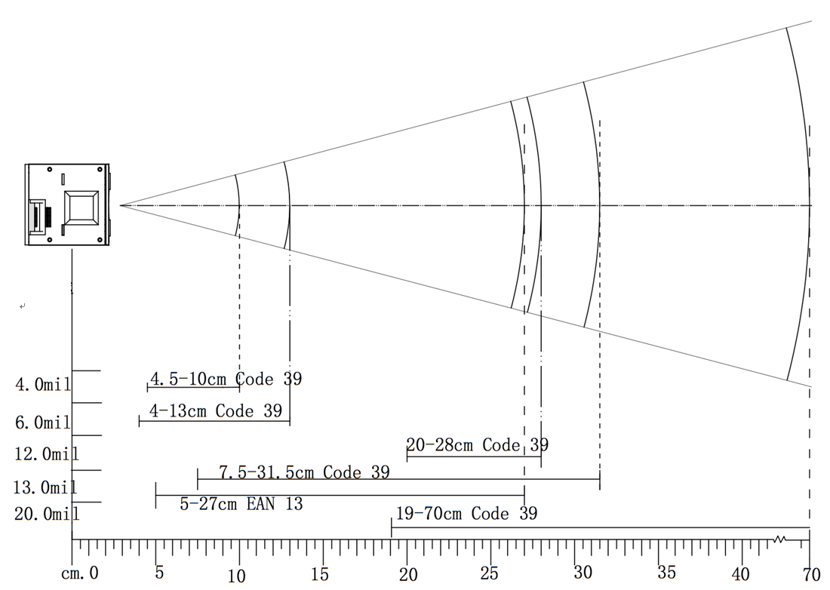

Symbology | Resolution  mm(mil) | Depths of Field | Digits
Code 39 | 0.101(4mil) | 4.5-10cm | 6
Code 39 | 0.152(6mil) | 4-13cm | 12
Code 39 | 0.30(12mil) | 20-28cm | 13
Code 39 | 0.33(13mil) | 7.5-31.5cm | 12
EAN 13 | 0.33(13mil) | 5-27cm | 13
Code 39 | 0.86(34mil) | 19-70cm | 10

