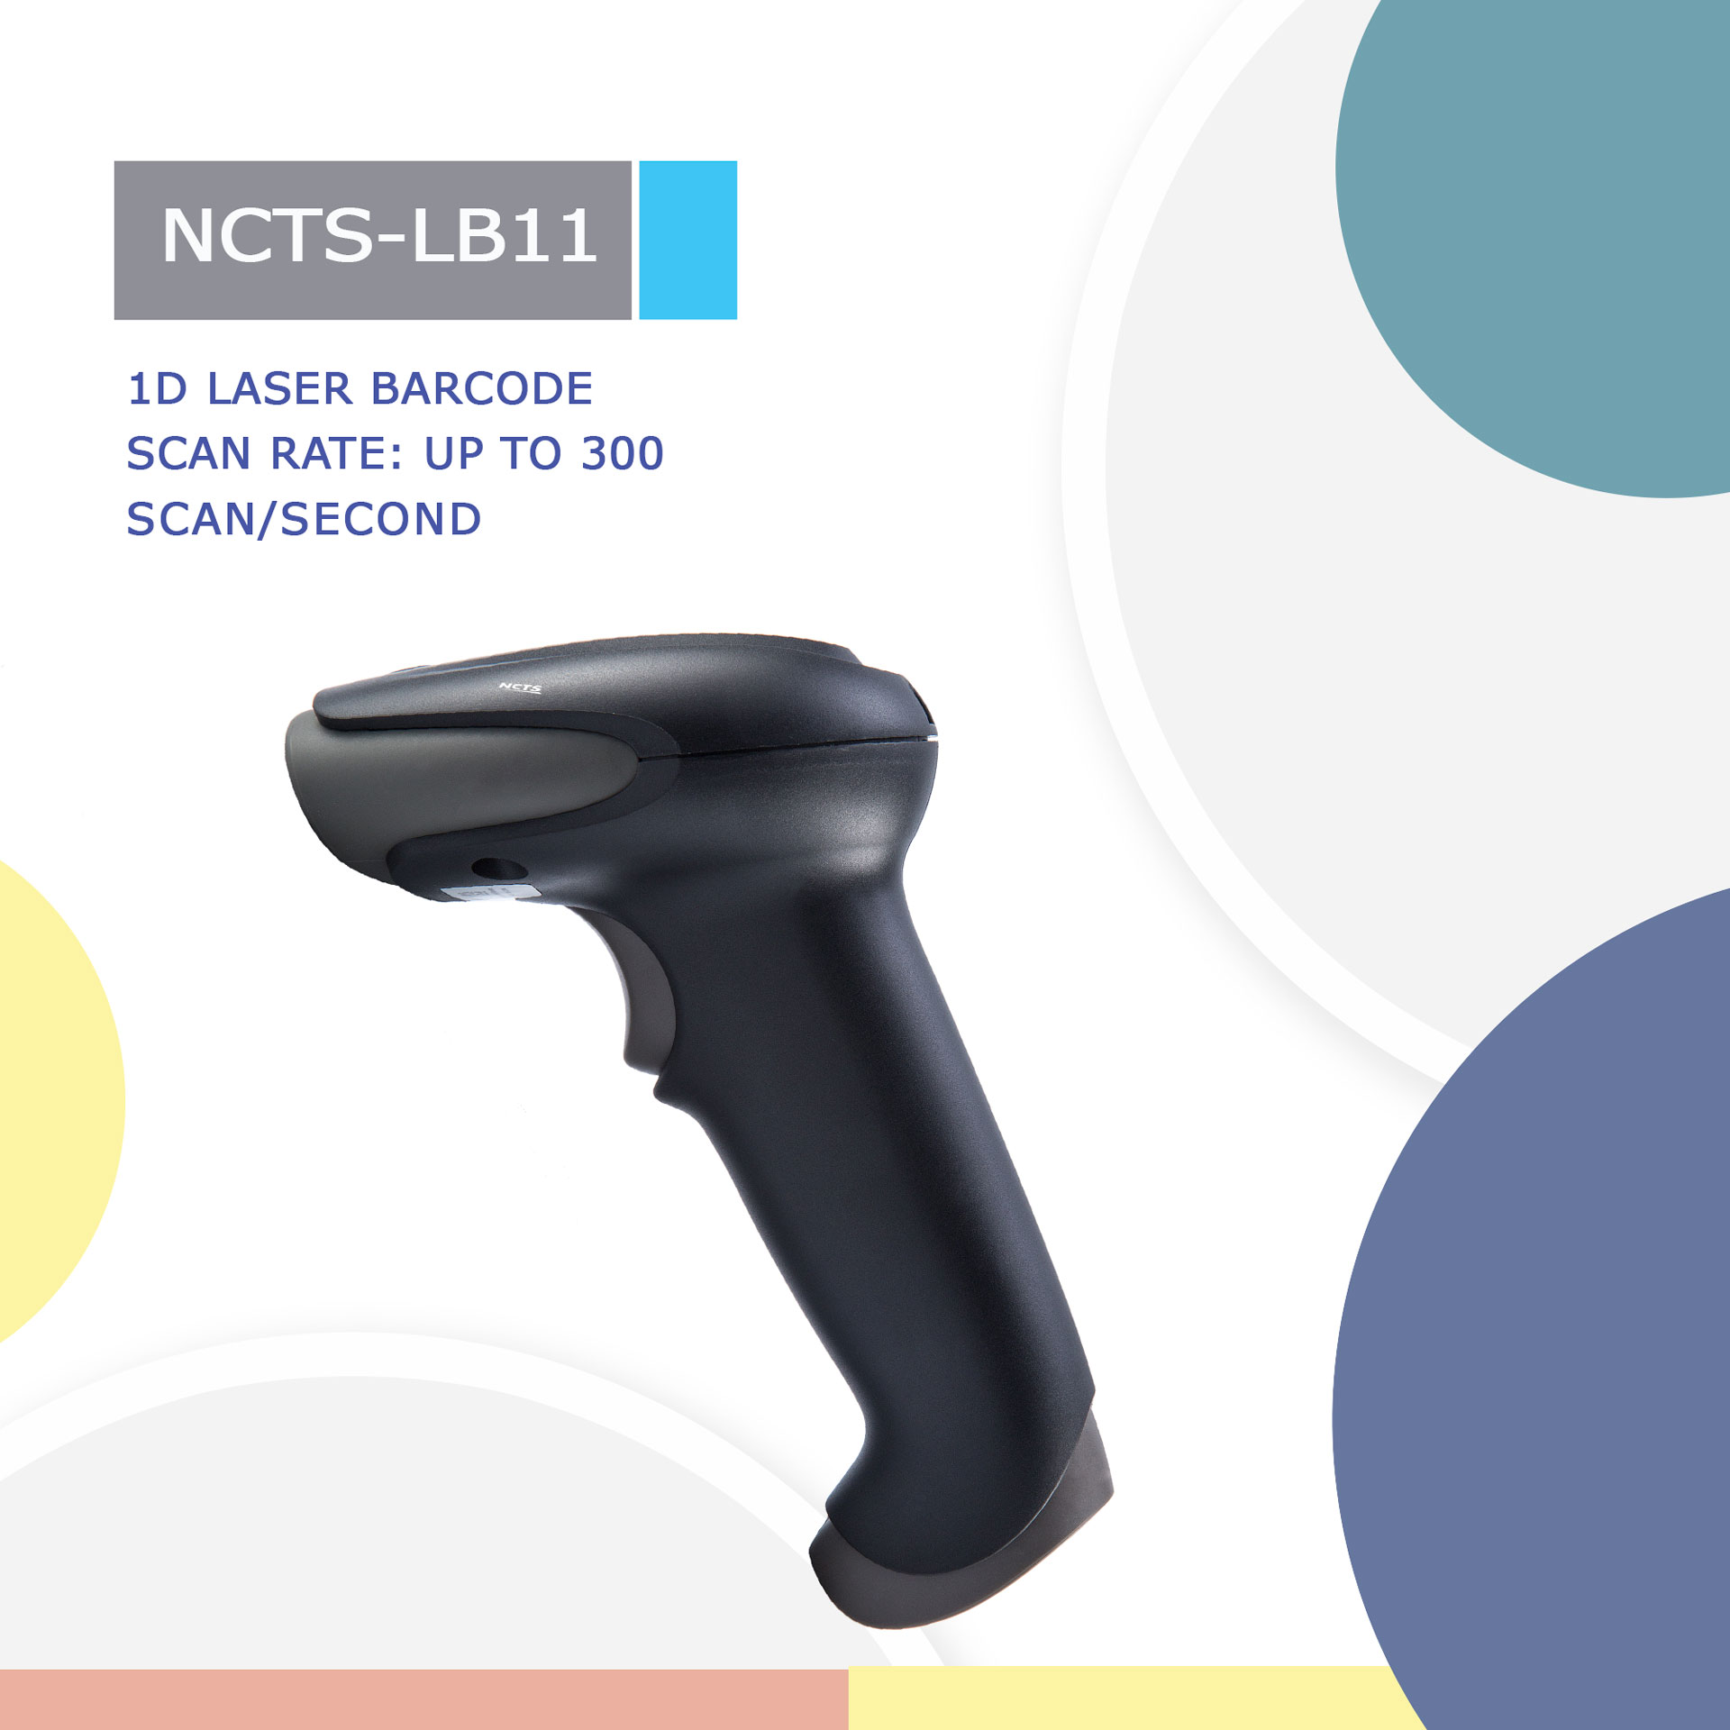

NCTS-LB11

Version:1.1

1D Barcode CCD Image Scanner
Technical Specifications
Electrical Characteristics
Interface Supported |  | RS-232/USB HID KEYBOARD/USB VCP
Input Voltage |  | DC 5V±10%
Current |  | Max:135mA
Optical Characteristics
Image Sensor |  | CCD Linear Sensor
Sensor Resolution |  | 1500pixels
Light Source |  | 632nm Red LED
Performance Characteristics
Decoding rate: |  | 350 scans/second±20 scans/second
Scanning Angle |  | Pitch angle:±35°;Skew angle:±75°;Tilt angle:±40°
Min Resolution |  | 0.127/5mil（PCS 0.9）
Min .PCS value |  | 〉25%UPC/EAN 13（13mil）
Language |  | Multiple Languages
Data Edition |  | Support for custom data output
Decode Capability |  | EAN13，EAN8，UPC A，UPC E，CODABAR（NW-7），CODE 39，CODE 93，INTERLEAVED 2OF5，STANDARD 2OF5，MATRIX 2OF5，CODE 128，EAN/UCC 128，CODE 11，CHINESE POST
Physical Characteristics
Dimensions |  | 90mm*67mm*168mm(L*W*H)
Weight |  | 130g
Indicator |  | Beeper, LED
Environmental Characteristics
Temperature |  | 0°∽50°C / 32°∽122°F(operation) /-10°∽60°C /14°∽140°F(storage)
Humidity |  | 20 - 85% (operation) ) 20 - 90% (storage)
Shock Drop Test |  | 1.5m drop onto concrete surface
Decoding Depth of Field
Symbology | Resolution |  | Barcode number | Barcode width | Nearest | Farthest
Code 128 | 5mil |  | 20 | 4.3x1.5cm | 9cm | 12cm
Code 128 | 15mil |  | 7 | 4.3x1.5cm | 7.5cm | 20cm
Code 39 | 6.67mil |  | 16 | 4.4x1.5cm | 8.5cm | 15.5cm
Code 39 | 20mil |  | 4 | 4.3x1.5cm | 7cm | 21cm
EAN-13 | 13..34mil |  | 13 | 4.2x1.5cm | 8cm | 17cm

