NBR3W/NPR3B
Thermal Printer
Instructions

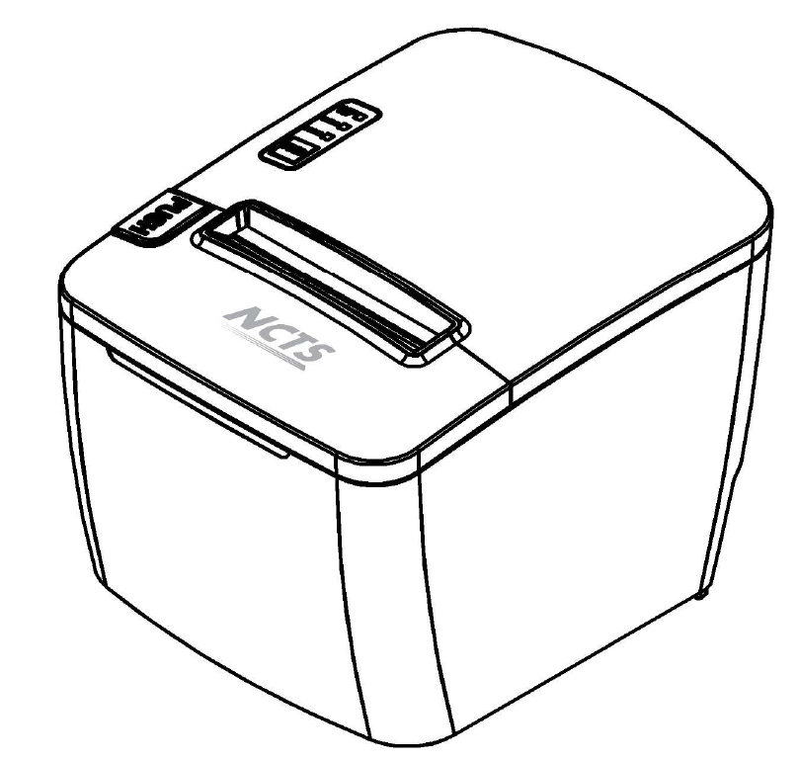

（Ver 1.00）

Content

Content 0
Introduction 2
Chapter 1 Feature and Performance 2
1.2 Print Paper 3
1.3 Print Font 3
1.4 Interface 3

1.5 Print Control Commands 3
1.6 Power Supply 4
1.7 Operation Environment 4
1.8 Outline Dimension 4
1.9 Type 4
Chapter 2 Operation Specification 5
2.1 Printer Appearance 5
2.2 Paper Installation 5
2.2.1 Paper Loading 5
NPR3W/NPR3B adopts thermal paper roll with width of 79.5mm. 5
2.2.2 Solution to Paper Jam 6
2.3 Interface 6
2.3.1 Serial Interface 6
2.3.2 Cash Drawer Interface 7
2.3.3 Power Connection 12
2.4 Buttons and Indicators 12
2.5 Normal startup state 14
2.6 Selftest 14
2.7 Hexadecimal Printing 16
2.8 Entering upgradeing mode 16

Introduction
NPR3W/NPR3B printer is a new line thermal printer, it features in fast speed, low noise, high reliability, perfect quality and ribbon needless, avoiding the vexation of regular maintenance.

NPR3W/NPR3B printe is small in outline dimension, simple with operation, and extensive with application, it is especially suitable for commercial cash register, PC-POS, POS bank and all kinds of related industries.

Warning
This is a class A product. In a domestic environment this product may cause radio interference in which case the user may be
required to take adequate measures.

Chapter 1 Feature and Performance
1.1 Print Performance
● Print method: direct thermal
● Print paper width: 79.5±0.5mm
● Print density: 8 dots/mm, 576 dots/line
● Print speed: approx.250mm／sec.
● Reliability
(1)Print head life: 150km
Using condition:
＊Print 12 × 24 ASCII characters, print 50 lines each time, intermittent print repeatedly
＊Each dot-line printing at the same time should not exceed 25%, each character line and one dot vertical printing repeatedly should not exceed 11 times
＊Use specified thermal paper
（2）Cutter life: 1,000,000 cuts
Using condition: less than 30 cuts/minute
● Valid print width: 72mm

1.2 Print Paper
● Thermal paper roll model: TF50KS－E（Japan paper co.ltd）
AF50KS-E (JUJO THERMAL)
● Thermal paper roll: Width－－－ 79.5±0.5mm
Outer Diameter －－－ 80mm（max.）
Inner Diameter－－－ 13mm（min.）
Thickness －－－ 0.06mm～0.08mm

1.3 Print Font
● ANK Character Set
12×24 dots，1.5（W）×3.00（H）mm
● GB GB2312-80(Chinese):
24×24 dots，3.00（W）×3.00（H）mm.

1.4 Interface
● RS－232C Serial Interface：
DB-25 socket, supports XON/XOFF and TR/DSR protocols.
Baud rate:2400,4800,9600,19200,38400,57600,115200bps .
Data structure: 1start bit + (7 or 8) data bits + 1 stop bit.
Parity checking: no parity or odd, even parity optional.
● USB Interface：
Mini USB interface

1.5 Print Control Commands
●commands Character print: support double-width, double height print of ANK characters, user-defined characters and Chinese characters, the character line spacing is adjustable.
● Graphics print commands: support the print of bit-map graphics and download bit-map graphics with different density
● GS bar code print commands: support UPC-A，UPC-E，EAN-13，EAN-8，CODE39，ITF，CODEBAR，CODE93，CODE128,PDF417,QR bar code print.

1.6 Power Supply
● DC24V±10％，2A，A-1009-3P power socket.

1.7 Operation Environment
● Operation temperature: 5～50℃; Relative humidity: 10～80％
● Storage temperature: -40～55℃; Relative humidity: 10～90℃

1.8 Outline Dimension
●197（L）mm×150（W）mm×133（H）mm

1.9 Type
type | Interface | colour
NPR3W | USB+ Internet interface+ RS－232C serial interface | White
NPR3B | USB+ Internet interface+ RS－232C serial interface | black

Chapter 2 Operation Specification

2.1 Printer Appearance
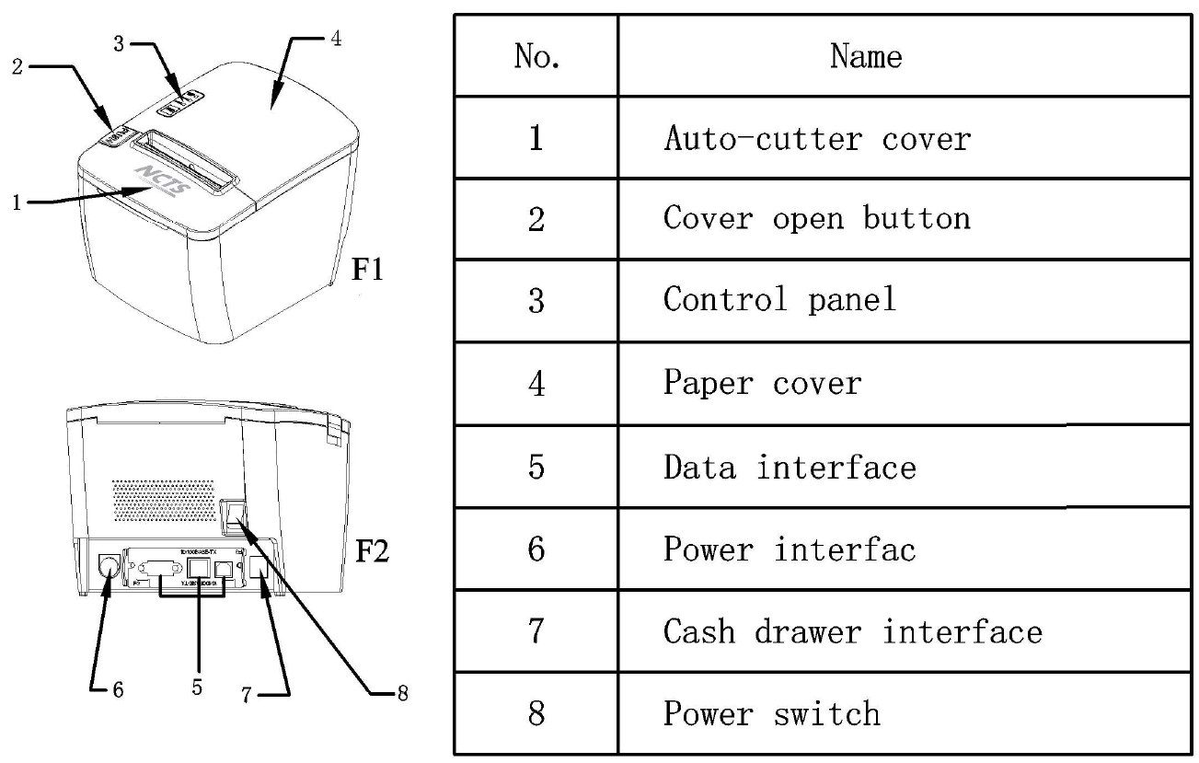

2.2 Paper Installation

2.2.1 Paper Loading

NPR3W/NPR3B adopts thermal paper roll with width of 79.5mm.
Steps of Loading Thermal Paper are as below:
Press the upper cover button on the left side, open the movable upper cover, put paper into the printer and draw the side of the paper roll, put the paper endings on the print head, close the upper cover and press it downwards lightly.

！Caution!

1.Pay attention to the direction of loading paper,make the printing surface face to the print head.
2.Please don’t feed or draw the paper forwards or backwards with hands.
3.Keep clean of the print head,avoid to influence the printing quality.

2.2.2 Solution to Paper Jam
If cutter is jammed,turn off the power and turn it on after a while,the cutter will be OK.If paper is jammed,open the paper cover,and take out the paper.If the cutter can not be OK,open the cover,and turn the white plastic gear by hand to make the cutter be OK.
If cutter is jammed and you do not want to lose the datas ,you should open the cover without turning off the power and pull the paper out .Printer will recovered by itself.

2.3 Interface

2.3.1 Serial Interface
The serial interface of printer NPR3W/NPR3B is compatible with RS-232C, and supports DTR/DSR and XON/XOFF handshaking protocols,the socket is DB9 socket (female). The pin order of the serial port is as Fig.2-2 shows:

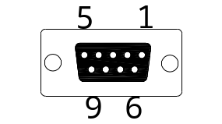
Fig.2-2 Pin Order of Serial Port

The pin assignment of serial interface is shown in Fig. 2-3:

Pin No. | Signal Name | Signal Direction | Source | Description
2 | TXD | Output | Printer | Printer transmits control code X-ON/X-OFF and data to host
3 | RXD | Input | Host | Printer receives data from host
6 | DSR | Input | Host | Signal “MARK” means the host is busy and can not receive data.Signal “SPACE” means the host is ready to receive data.
8 | CTS | Input | Host | DSR
5 | GND | —— | —— | Signal Ground

Fig. 2-3 The pin assignment of serial interface
Note: (1)“Source” denotes the source that signal come from;
(2)Logical signal level is EIA.

The baud rate and data structure under serial interface mode is separately 115200bps, 8-bit data bits, no parity bit and 1 stop bit.
The serial interface of NPR3W/NPR3B can be connected to standard RS-232C interface.

2.3.2 Cash Drawer Interface
The cash drawer interface of printer NPR3W/NPR3B adopts J-11 6-pin socket, as Fig.2-7 shows:
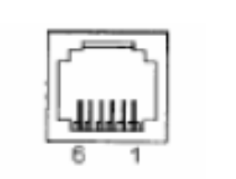
Fig.2-7 Cash Drawer Interface
The pin assignment is as below：
Pin No. | Signal | Direction
1 | Chassis Ground | ——
2 | Cash drawer driver signal 1 | Out
3 | Cash drawer on/off status signal | In
4 | +24VDC | ——
5 | Cash drawer driver signal 2 | Out
6 | Signal ground | ——

2.3.3 Power Connection

The external power supply for printer NPR3W/NPR3B adopter is 24V±10％、2A and the power socket is A-1009-3P model,as Fig. 2-10 shows:

Fig.2-8 Power Socket
The pin assignment is as below：
Pin No. | Signal
1 | +24VDC
2 | Ground
3 | NC

2.4 Buttons and Indicators
There is one button，one buzzer and three indicator in printer NPR3W/NPR3B.【FEED】 button is for feeding paper,the button can be controlled by the printing order.when the button is permitted to ues ,you can press the button and the paper will feeding automatically and it will stop when you release the button.
The buzzer indicates the wrong situation and situations for paper cutting.You can set buzzers with parameters to alarming for wrong situation and paper cutting tip and the buzzer can alarm for both at the same time. The reflection of the wrong situation is the same as ERROR light.
The green POWER light is indicator for power and red ERROR light is indicator for status.
The red indicater light is for printing paper and it means being out of paper when the light flashes.
The red ERROR light is indicater for wrong situation.It is off when the printer work normally and it flashes when printer is wrong.It will always flash when the paper cover is open.

When ERROR flashes and buzzer rings ，it means printer is wrong.According to different flashing way,the problem of printer is different as following.
1. The mistake can’t be recovered when the indicator flashing some times and it keeps shining for a while. After times of cycle of the processs,the times of flashing means the type of mistake.
2. The mistake can be recovered when the indicator keeping flashing and keeps off for a while .
3. The mistake can be automatically recovered when the light keeps flahing.It also include mistakes about printer head temperature and paper cover.
4.When paper is out ,the light flashes and the buzzer keeps alarming.After opening the paper cover,the light will shows if there is paper but not whether being out of paper.
As following :
1. The mistake can’t be recovered when the indicator flashing some times and it keeps shining for a while. After times of cycle of the processs,the times of flashing means the type of mistake.

Error type | Description | ERROR
mistake can’t be recovered | LED flashes once : Memory read - write errors | 
mistake can’t be recovered | LED flash twice power is high | 
mistake can’t be recovered | LED flashes three times:power is low | 
mistake can’t be recovered | LED flashes four times : Execution error(wrong addression ) | 
mistake can’t be recovered | LED flashes five times : UIB is wrong | 
mistake can’t be recovered | LED flashes eight times : temperature detection of circuiti is wrong | 

2. The mistake can be recovered when the indicator keeping flashing and keeps off for a while .

Error type | Prescription | Type of flash
mistake can be recovered | LED flashes once .the place of cutter is wrong | 

3. The mistake can be automatically recovered when the light keeps flahing.It also include mistakes about printer head temperature and paper cover.

Error type | Description | Type of flash
The mistake can be automatically recovered | LED continues flashing ：the temperature of printer head is high and the cover is wrong | 

2.5 Normal startup state
When power is off and the paper cover is closed ,turn on the power , the status light and paper light flashes twice alternately.Then turn off the light and the printer will work normally.

2.6 Selftest
The Self-test procedure can test the work condition of printer.if the printer can print the self-checking spline,it means the printer can work. The content of selftest spline should be 96 ANK characters,defalut code page,name of Chinese Characrer library, interface setting and software. Method for self-test:press【FEED】button and turn on the power， The result is as following:

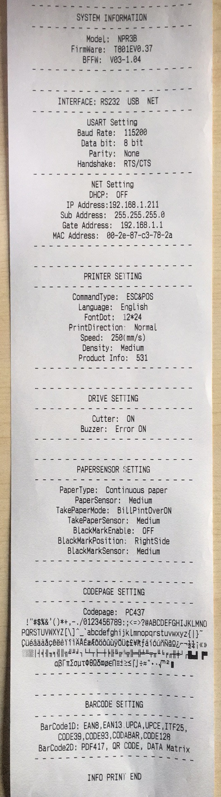
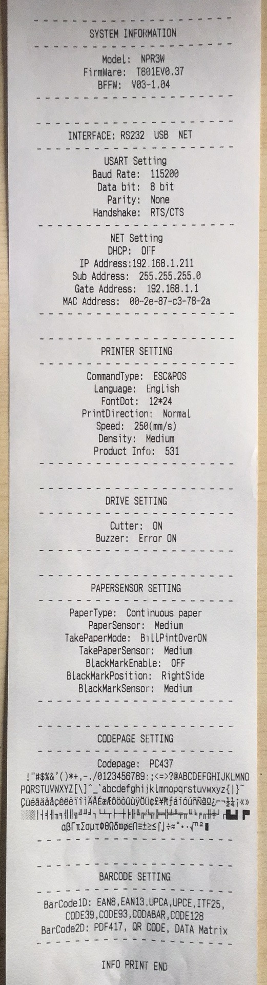

2.7 Hexadecimal Printing
Turn on the printer according to the step below,it will enter the mode of Hexadecimal Printing
1.Open the paper cover.
2.Press【FEED】button，and connect with the power.
3.Close the cover,the printer will print out 3 lines as below:
Hexadecimal Dump
To terminate hexadecimal dump,
Press FEED button three times.
This means the printer has entered hexadecimal printing mode,and under this mode,all of the input will be printed out as hexadecimal number,feed one line with single-click of “FEED” button,after 3 times,it will print out “*** Completed ***”,and exit hexadecimal printing mode.

2.8 Entering upgradeing mode
When printer is not connected with power,open the paper cover,press on the 【FEED】 button,then turn on the printer, ERROR light flashes four, release the 【FEED】 button ,then press 【FEED】 button four times,then turn on the paper cover, Now printer is under upgrading mode and two status lights will alternating flash.



