NCTS CBB2

Highlights
♦ Reads Bar Codes on Various Media
Not only read codes on printed paper, it could also read codes on mobile phones and computer displays, with this scanner, you will be ready for the coming mobile barcodes revolution.
♦ Using Bluetooth wireless transmission technology
NCTS CBB2 Bluetooth barcode scanner supports 10 meters wireless transmission, has big memory of 500 pcs 13 bytes barcodes, real time and inventory different modes to meet the needs of different applications. 2.0 version 30 meters long distance’s Bluetooth barcode scanners are coming soon.
♦ Superior decoding performance
High resolution:648x488 pixels fast and accurate . Low decoding error rate can help to improve your working efficiency.
♦ Perfect process design and ultimate experience
NCTS CBB2 uses imported ABS material, high quality rubber is a good buffer against impact. Nice design makes it different and popular. It applies to cashier for mobile payment and Logistics & Express.
♦ Long life span
Shockproof and Anti-broken
NCTS CBB2 barcode scanner, after 1.2 drop onto concrete surface floor, still works well.
Famous brand C&k button
NCTS barcode scanner uses world famous brand C&k trigger button, even after 1500，000 times trigger, it still works normally.

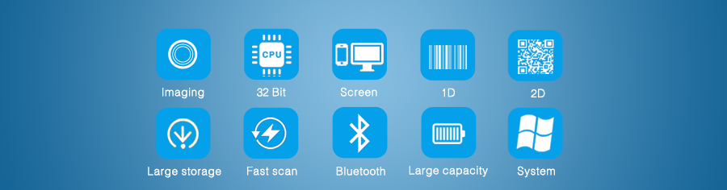
Product Details
► NCTS barcode scanners are compatible with almost all common systems, as Windows, Android, Mac OS, IOS, Linux etc.
► NCTS barcode scanners support multiple keyboard language: USA, Germany, French, Italy, Spanish, Turkey, Belgium, Brazil Czech and so on.
► Support Custom Function: such as add a prefix/suffix, delete the last four characters, interlaced upload data...
► Support self-upgrade, as no limitation for Keyboard Cash.
► 32 Bite CPU, highly efficient, and greatly improves the working efficiency.
► Can be adjusted the working mode of barcode scanner according to your own needs, as continuous reading or single reading, scan the same barcode or not, delay the time to upload data or not....
► NCTS barcode scanners apply to registry office of the airport/train station, hospitals, warehouses, supermarkets, retail stores, libraries, catering, logistics, express delivery, etc.
► Support multi-barcodes, such as: 1D：UPC/EAN, Code 128, Code 39, Code 93, Code 11, Matrix 2 of 5, Interleaved 2 of 5, Coda bar, MSI, GS1 Data bar 2D：QR, PDF417, Data Matrix

