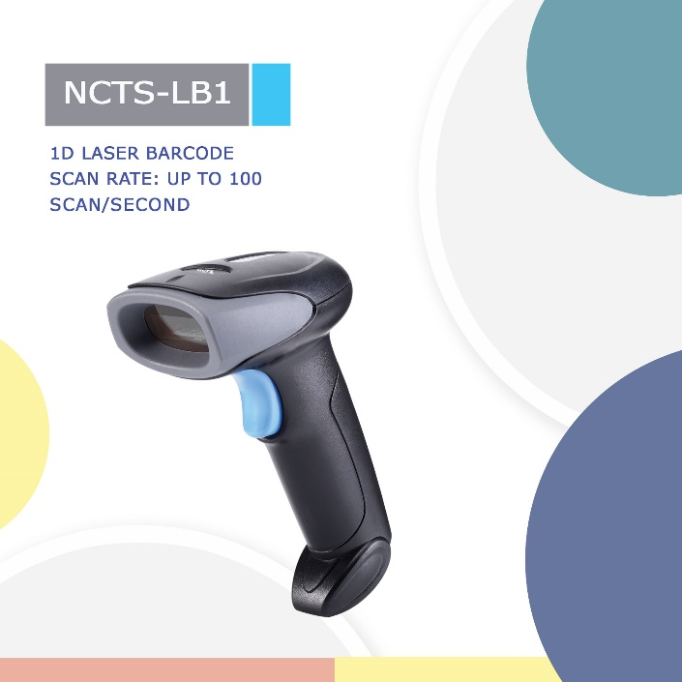
NCTS-LB1

(1D Laser Wired Hand held Barcode Scanner)

Technical Parameters
Electrical Characteristics
Interface | USB HID KEYBOARD/USB VCP/RS-232
Voltage requirement | DC 5V±10%
Current consumption | Max:120mA
Optical Characteristics
Light source | 650nm visible laser diode
Performance Characteristics
Operating mode | single read  multiple read  Continuous read
Scan Rate: | 100 scans/second± 20 scans/second
Decode angle | Pitch angle: ±30°  Skew angle: ±60°  Tilt angle:±40°
curvature | R≥15 mm (EAN8)，R≥20 mm (EAN13)（resolution=0.26mm，PCS=0.9）
Min resolution | SR：0.127/5mil（PCS 0.9）
Min .PCS value | 〉30%UPC/EAN 13（13mil）
error rate | 1／500W
Language | multiple languages
Identification | EAN13，EAN8，UPC A，UPC E，CODABAR（NW-7），CODE 39，CODE 93，INTERLEAVED 2OF5，STANDARD 2OF5，MATRIX 2OF5，CODE 128，EAN/UCC 128，CODE 11，CHINESE POST
Physical Characteristics
Dimensions | 97 mm x 67 mm x165mm (L*W*H)
Weight | 178.9g
Environmental Characteristics
Temp | -20°-65°C / -4° to 149°F((operation) ) -30°- 70°C /-22° to 158°F(storage)
Humidity | 5 - 90% (operation) ) 5 - 90% (storage)
Ambient Light: | fluorescent light 4000 lx max , direct sun light 80,000 lx max ,white light 4000 lx max
Shock drop test | 1.5m drop onto concrete surface
MBTF | 30,000 hours except laser diode (10.000 hours) and except mirror scan unit (10,000 hours)
Regulatory
Laser Safety | JIS-C-6802 Class 2
Electrical Safety | UL 60950，EN/IEC 60950
EMI/RFI | FCC Part 15 Class B,EN 55024/CISPR 22
Environmental | RoHS

Depth of field
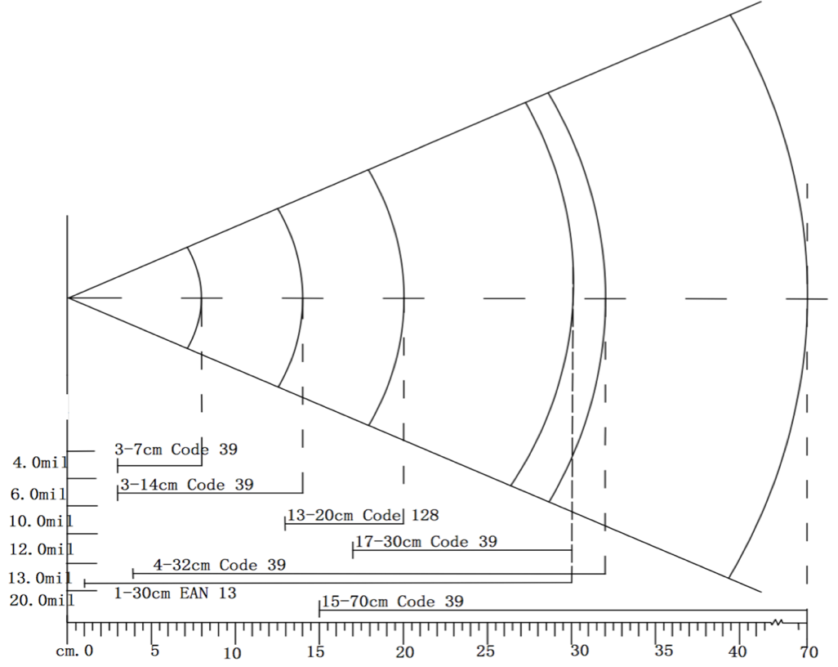
Symbology | Resolution（mm） | Depth of field（mm）
Code 39 | 4mil | 3-7cm
Code 39 | 6mil | 3-14cm
Code 39 | 10mil | 13-20cm
Code 39 | 12mil | 17-30cm
EAN 13 | 13mil | 1-30cm
Code 39 | 20mil | 15-70cm

